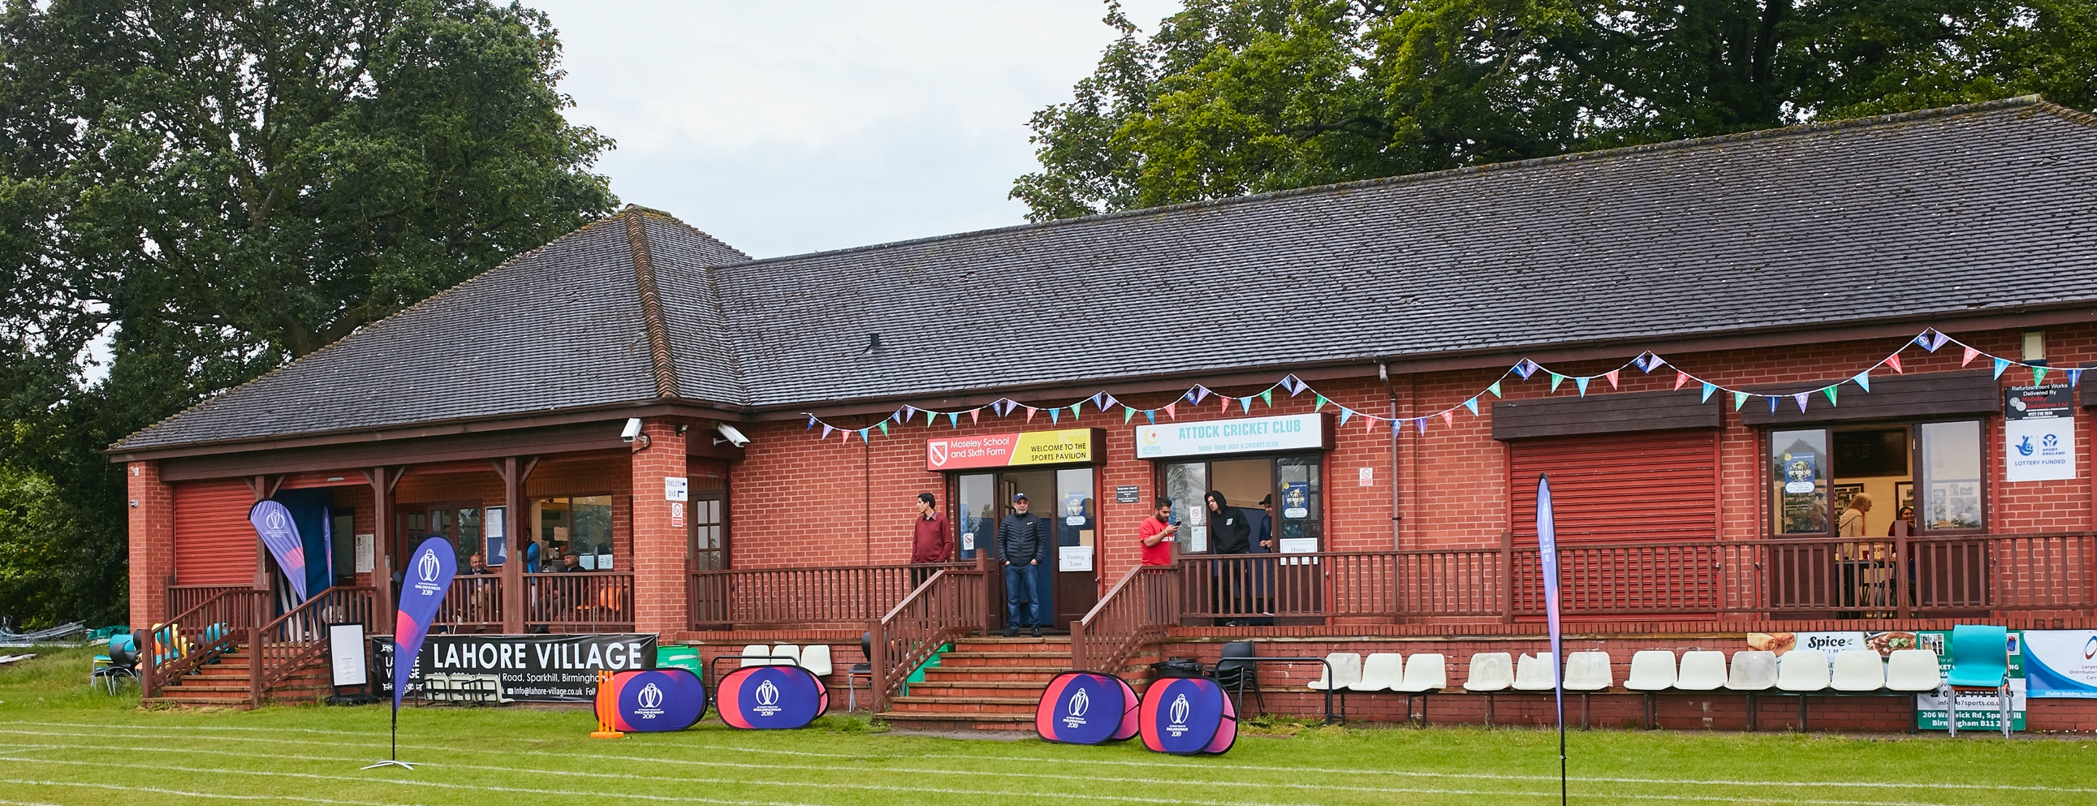

RISK ASSESSMENT – Oswestry Cricket Club
Risk Assessment
As a facility provider, you should complete your own COVID-19 Risk Assessment and publish this to your users.

If you are not the facility provider, then you should consider which sections will apply to your clubs individual situation upon returning to play and complete a risk assessment based on your activity, including (but not limited to) people management and communication, hygiene and first aid. You may still wish to record that you have assessed facility risks through enquiries made with your facility provider.

We have provided an example risk assessment below, which is for illustrative purposes only, and includes some examples of things to consider. Consider how this will apply to each aspect of your operation and identify the controls you require to meet Government guidance regarding health, social distancing and hygiene etc. Remember that you must review your other Health and Safety, and Safeguarding, risk assessments for other hazards such as fire, first aid etc.

What are the hazards? |  | Transmission of COVID-19
Who might be harmed? |  | Facility users, staff, volunteers, visitors, and the wider community
No | Controls required |  | Action Taken by the Club
People Management and Communication
 | Self-screening of individuals before they arrive at the venue to ensure individuals displaying COVID-19 symptoms or those who should be shielding do not travel or attend. |  | All members informed that if they display any signs of Covid-19 to self -isolate and follow Government guidelines. Communication by email, Social Media and posters situated around Club.
 | An assessment of user numbers, space capacities, venue circulation and layout planning to maintain social distancing. |  | Full Risk assessment completed for club house, one-way system in place, reduced seating, and indoor numbers (when allowed). Covid-19 signage situated around club.
 | A plan for where parents and players will sit whilst watching cricket activities. |  | Players have separate part of ground in front of changing rooms away from spectators and parents, players area is clearly signposted.
 | Signage and communication so that all participants and visitors are aware of the control measures in place and how to act appropriately to minimize the risk of transmission of COVID-19. |  | Covid-19 & social distancing signs placed around clubhouse both inside and outside. Rules & Guidelines clearly displayed for both inside and outside.
 | Staff and volunteer training to support the implementation of the plan, with suitable training records. |  | All relevant members, coaches, and staff made fully aware of all risk assessments, Playing, Clubhouse, toilets, and coaching.
Buildings
 | Assess ventilation in your building (natural and mechanical) and take appropriate measures to maximise ventilation and minimise risk of transmission. |  | Front door to remaining open at all times, end double door exit to remaining open at all times, skylights also to be open at all times.
 | Assess the maximum occupancy of your rooms at 2m social distancing (or 1m with risk mitigation where 2m is not possible) and establish a suitable circulation system/one-way system. Use signage and floor markings to communicate this. |  | Changing rooms to remain closed, players to use toilet opposite the away changing room. Please see full Clubhouse RA for all other information.
 | Assess the arrangement of seating areas to maintain social distancing and minimise the risk of transmission. |  | Reduced seating inside building, maximum of 25 people in club (when allowed). Outside picnic benches all placed within social distancing guidelines.  Players and Officials to have own cordoned off part of the veranda and ground
 | Consider your wet weather plans and describe what actions you will take to maintain social distancing in wet weather. |  | Players and Officials to utilise their cordoned of part of the veranda and Gazebo or their own vehicles. Kit bags to be left outside or in car.
Social and Hospitality Areas
 | Plan to solicit and maintain records of your member attendance, customers, and visitors - to be maintained for 21 days and then destroyed. |  | All Members, customers, and visitors to provide contact details inline with government guidelines. Details destroyed after 21 days. NHS Check in QR code situated around club and ground
 | Identification of suitable areas for outdoor service that don’t overlap with cricket activity. |  | Spectators area will be separate and cordoned off from players and officials.
 | Steps taken to minimise time and the number of people at the bar. |  | Table service inside (when allowed) and outside. One-way system and social distancing measures in place in bar area. (see bar risk assessment)
 | Steps taken to minimise contact points at payment or around the hospitality space. |  | Preferred method of payment is contactless card, cash will be accepted. This is displayed around club.
 | Suitable PPE provision and training for staff and volunteers. |  | Facemasks, gloves, and sanitizer available to all staff and volunteers.
 | Strategy for the safe serving, clearing, and cleaning of glassware and tableware. |  | Please see Clubhouse RA
 | Deep cleaning strategy to minimise COVID-19 transmission risk |  | Please see Clubhouse RA
 | Daily cleaning strategy to minimise COVID-19 transmission risk. |  | Please see Clubhouse RA
 | High-frequency touchpoint cleaning strategy to minimise COVID-19 transmission risk and how you will keep records. |  | These will be cleaned every hour with a spray disinfectant and logged on cleaning schedule – See attached.
Hygiene and Cleaning
 | Materials, PPE, and training that you have provided to your staff for effective cleaning. |  | All staff briefed with cleaning schedules and clubhouse RA
 | Provision of hand washing facilities with warm water, soap, disposable towels, and bin. |  | Hot water and soap available in all toilets.
 | Provision of suitable hand sanitiser in locations around the facility to maintain frequent hand sanitisation. |  | Sanitizer available by entrance, exit, toilets, and bar. These are highlighted by visual aids.
 | Provision of suitable wipes and hand sanitiser on the field for hygiene breaks. |  | All player and officials to bring their own sanitizer, club will provide wipes for ball and breaks.
 | What are the hazards? | Other venue hazards to be considered after temporary closure such as Legionnaire’s Disease, fire, electrical safety etc.
 | Who might be harmed? | Facility users, staff, volunteers, and visitors
 | Controls required |  | Action Taken by the Club
Preparing Your Buildings
 | Consider the risk of Legionnaire’s disease and carry out necessary work to make your water supply safe for users. Refer to the specific guidance in the document above. |  | Showerheads & Taps have been cleaned and treated.
 | Check that routine maintenance has not been missed and certification is up to date (e.g. Gas safety, Electrical Safety and Portable Appliance Testing, Fire Safety, Lifts and Heating – Ventilation and Air Conditioning). |  | All up to date
 | Check that your ground is ready and safe to play. Look at what work is required and how this can be done safely at a social distance. |  | Ground has been maintained throughout lockdown. All work completed within Government Guidelines.
 | What are the hazards? | Vital first aid equipment is not available when needed. First aiders do not have adequate PPE to carry out first aid when required.
 | Who might be harmed? | First aiders, facility users, staff, volunteers, and visitors
 | Controls required |  | Action Taken by the Club
First Aid
 | Check that your first aid kits are stocked and accessible during all activity. |  | New First Aid kits brought for all captains, new fixed station set up by changing rooms and 1 new portable kit. Defibrillator is sited behind the main bar.
 | What steps have you taken to improve your first aiders’ understanding of first aid provision under COVID-19? |  | All first aiders are aware of the Government guidance regarding the administration of first aid.
 | If you have an AED then check that it is in working order, service is up to date and that it is available during all activity. |  | All checked and in working order.
 | What are the hazards? | Pitches or outfield are unsafe to play on
 | Who might be harmed? | Players, officials, ground staff
 | Controls required |  | Action Taken by the Club
Preparing your Grounds
 | Safety checks on machinery, sightscreens and covers. |  | Completed as normal
 | Check and repair of any damage to pitches and outfields. |  | Completed as normal
 | Surfaces checked and watering regime adjusted based on lack of rainfall. |  | Completed as normal
 | What are the hazards? | Use this space to identify hazards at your venue:  Cricket balls flying around the ground. Falling tiles from the pavilion roof.
 | Who might be harmed? | Use this space to identify who might be harmed:  Players, officials, groundstaff, spectators and neighboring properties.
 | Controls required |  | Action Taken by the Club
 | Identify your own control measures required. |  | Installation of safety netting at appointed sites around the ground.  Erection of safety notices around ground  Outside tables & picnic benches not to be sited in front of pavilion during the hours of play.
 |  |  | Separate Risk Assessments completed for clubhouse bar, toilets, and coaching.
 | Changing Room from 17/5/2021 |  | Changing Rooms clean and showers treated for legionnaires. Maximum of 6 people in changing room at any one time. Windows should always be left open and if possible, the door too. Facemasks must always be worn inside the building including the changing rooms. Hand sanitizer will be placed in each changing room, this should be used every time someone enters. Regular cleaning of touch points and full clean after each game.

