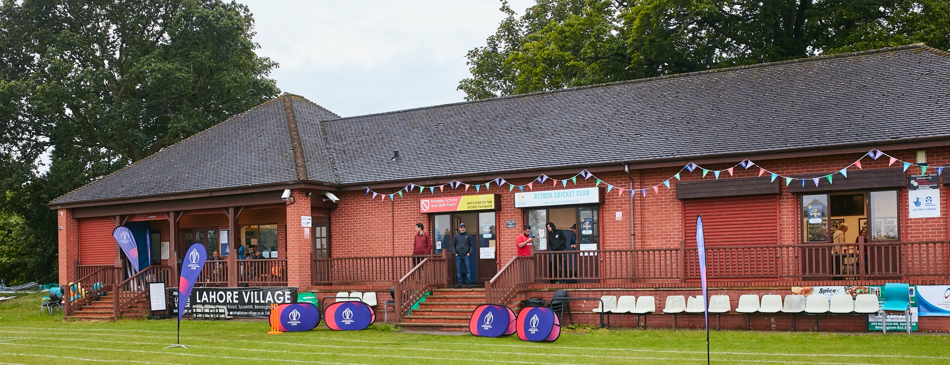

RISK ASSESSMENT TEMPLATE FOR CLUBS PREPARING TO OPEN THEIR CLUBHOUSE

Risk Assessment Template
As a facility provider, you should complete your own COVID-19 Risk Assessment and publish this to your users.

If you are not the facility provider, then you should consider which sections will apply to your clubs individual situation upon returning to play and complete a risk assessment based on your activity, including (but not limited to) people management and communication, hygiene and first aid. You may still wish to record that you have assessed facility risks through enquiries made with your facility provider.

We have provided an example risk assessment below, which is for illustrative purposes only, and includes some examples of things to consider. Consider how this will apply to each aspect of your operation and identify the controls you require to meet Government guidance regarding health, social distancing and hygiene etc. Remember that you must review your other Health and Safety, and Safeguarding, risk assessments for other hazards such as fire, first aid etc.

What are the hazards? |  | Transmission of COVID-19
Who might be harmed? |  | Facility users, staff, volunteers, visitors and the wider community
No | Controls required |  | Action Taken by the Club
People Management and Communication
 | Self-screening of individuals before they arrive at the venue to ensure individuals displaying COVID-19 symptoms or those who should be shielding do not travel or attend. |  | Notification to all AHCC members that ANYBODY with ANY COVID-19 symptoms MUST NOT attend or travel. Assumption is that the away team officials will conduct the same checks on their team. If anybody is identified as having symptoms, they will be asked to leave the playing area.
 | An assessment of user numbers, space capacities, venue circulation and layout planning to maintain social distancing. |  | Maximum rooms occupancy in changing rooms and kitchen displayed on entrance doors  Captains will ensure compliance on match day
 | A plan for where parents and players will sit whilst watching cricket activities. |  | Seating area set aside adjacent to the veranda at pitch side
 | Signage and communication so that all participants and visitors are aware of the control measures in place and how to act appropriately to minimise the risk of transmission of COVID-19. |  | Signage identifying hand sanitiser location, toilets, hygiene measures, QR code placed at numerous locations, who to notify upon arrival and a reminder of 2m social distancing at all times
 | Staff and volunteer training to support the implementation of the plan, with suitable training records. |  | All officials aware of this risk assessment. Uploaded to SCCL website
Buildings
 | Assess ventilation in your building (natural and mechanical) and take appropriate measures to maximise ventilation and minimise risk of transmission. |  | Changing room windows to be left open where possible, unless inclement weather
 | Assess the maximum occupancy of your rooms at 2m social distancing (or 1m with risk mitigation where 2m is not possible) and establish a suitable circulation system/one-way system. Use signage and floor markings to communicate this. |  | Maximum occupancy for each changing room displayed on the door.  Sports Club house has separate risk assessment placed on the entrance notice board.  Club house set up to be social distanced, one way systems, hand sanitiser at the entrance and QR scan code
 | Assess the arrangement of seating areas to maintain social distancing and minimise the risk of transmission. |  | Seating area set out aside the veranda
 | Consider your wet weather plans and describe what actions you will take to maintain social distancing in wet weather. |  | Undercover veranda area with social distancing. Surplus must use their own cars.  Investigate use of gazebos for open sided cover
Social and Hospitality Areas
 | Plan to solicit and maintain records of your member attendance, customers and visitors - to be maintained for 21 days and then destroyed. |  | Away captain to submit team players, coaches, scorers and spectators to the home captain prior to the game.  Home captain to collect a register of the home team players, coaches, scorers, spectators and officials. Home scorer to keep the records for 21 days.
 | Identification of suitable areas for outdoor service that don’t overlap with cricket activity. |  | Seating area will be marked. No other overlap areas.
 | Steps taken to minimise time and the number of people at the bar. |  | Full sports club risk assessment has been conducted and is placed on the notice board as you enter the sports club.
 | Steps taken to minimise contact points at payment or around the hospitality space. |  | Payment by contactless where possible. Where cash, hand sanitisers are provided and to be used after every transaction
 | Suitable PPE provision and training for staff and volunteers. |  | Only required for first aiders in case of emergency
 | Strategy for the safe serving, clearing and cleaning of glassware and tableware. |  | Covered in the sports club risk assessment
 | Deep cleaning strategy to minimise COVID-19 transmission risk |  | Covered in the sports club risk assessment
 | Daily cleaning strategy to minimise COVID-19 transmission risk. |  | Covered in the sports club risk assessment
 | High-frequency touchpoint cleaning strategy to minimise COVID-19 transmission risk and how you will keep records. |  | Covered in the sports club risk assessment
Hygiene and Cleaning
 | Materials, PPE and training that you have provided to your staff for effective cleaning. |  | PPE and hand sanitiser provided by NatWest pre season and is available.  End of game cleaning to take place.
 | Provision of hand washing facilities with warm water, soap, disposable towels and bin. |  | Hand washing facilities available within the toilets
 | Provision of suitable hand sanitiser in locations around the facility to maintain frequent hand sanitisation. |  | Available at the cricket ground and at entry to the sports club. Players to also provide their own.
 | Provision of suitable wipes and hand sanitiser on the field for hygiene breaks. |  | Available at the cricket ground, and individuals to provide their own
 | What are the hazards? | Other venue hazards to be considered after temporary closure such as Legionnaire’s Disease, fire, electrical safety etc.
 | Who might be harmed? | Facility users, staff, volunteers and visitors
 | Controls required |  | Action Taken by the Club
Preparing Your Buildings
 | Consider the risk of Legionnaire’s disease and carry out necessary work to make your water supply safe for users. Refer to the specific guidance in the document above. |  | Flushing and temperature checks to be completed
 | Check that routine maintenance has not been missed and certification is up to date (e.g. Gas safety, Electrical Safety and Portable Appliance Testing, Fire Safety, Lifts and Heating – Ventilation and Air Conditioning). |  | Electrical testing and PAT testing completed
 | Check that your ground is ready and safe to play. Look at what work is required and how this can be done safely at a social distance. |  | Completed as per the grounds man guidance
 | What are the hazards? | Vital first aid equipment is not available when needed. First aiders do not have adequate PPE to carry out first aid when required.
 | Who might be harmed? | First aiders, facility users, staff, volunteers and visitors
 | Controls required |  | Action Taken by the Club
First Aid
 | Check that your first aid kits are stocked and accessible during all activity. |  | All first aids kits are stocked and kept in the kitchen and with team officials. Numerous first aiders available.
 | What steps have you taken to improve your first aiders’ understanding of first aid provision under COVID-19? |  | Shared the St John’s Ambulance guidance and introduced additional PPE as per the ECB guidance
 | If you have an AED then check that it is in working order, service is up to date and that it is available during all activity. |  | N/A
 | What are the hazards? | Pitches or outfield are unsafe to play on
 | Who might be harmed? | Players, officials, ground staff
 | Controls required |  | Action Taken by the Club
Preparing your Grounds
 | Safety checks on machinery, sightscreens and covers. |  | Qualified groundsmen as per every other year
 | Check and repair of any damage to pitches and outfields. |  | Review of playing area during ground work and pre match
 | Surfaces checked and watering regime adjusted based on lack of rainfall. |  | Qualified groundsmen as per every other year
 | What are the hazards? | Use this space to identify hazards at your venue
 | Who might be harmed? | Use this space to identify who might be harmed
 | Controls required |  | Action Taken by the Club
 | Identify your own control measures required.

 | What are the hazards? | Use this space to identify hazards at your venue
 | Who might be harmed? | Use this space to identify who might be harmed
 | Controls required |  | Action Taken by the Club
 | Identify your own control measures required.

 | What are the hazards? | Use this space to identify hazards at your venue
 | Who might be harmed? | Use this space to identify who might be harmed
 | Controls required |  | Action Taken by the Club
 | Identify your own control measures required.

