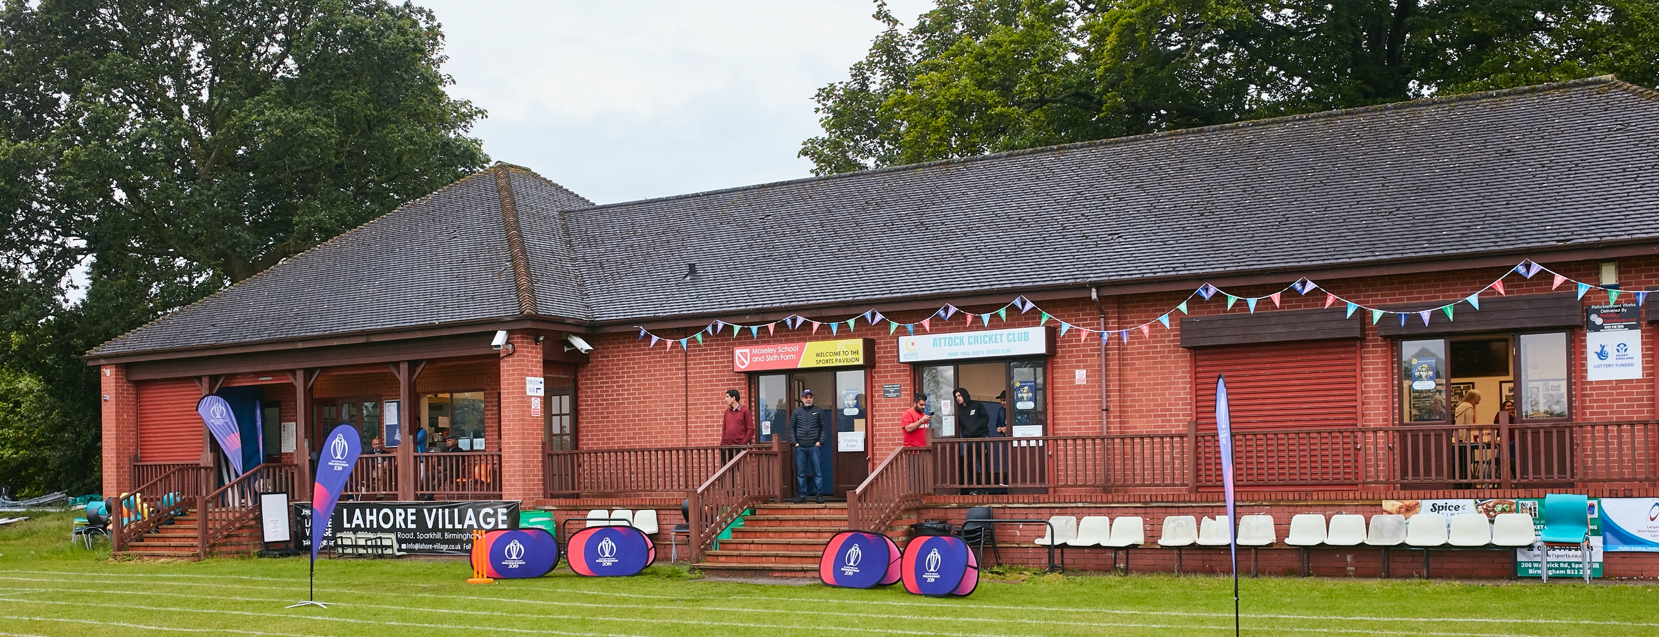


RISK ASSESSMENT TEMPLATE FOR CLUBS PREPARING TO OPEN THEIR CLUBHOUSE

Risk Assessment Template
As a facility provider, you should complete your own COVID-19 Risk Assessment and publish this to your users.

If you are not the facility provider, then you should consider which sections will apply to your clubs individual situation upon returning to play and complete a risk assessment based on your activity, including (but not limited to) people management and communication, hygiene and first aid. You may still wish to record that you have assessed facility risks through enquiries made with your facility provider.

We have provided an example risk assessment below, which is for illustrative purposes only, and includes some examples of things to consider. Consider how this will apply to each aspect of your operation and identify the controls you require to meet Government guidance regarding health, social distancing and hygiene etc. Remember that you must review your other Health and Safety, and Safeguarding, risk assessments for other hazards such as fire, first aid etc.

What are the hazards? |  | Transmission of COVID-19
Who might be harmed? |  | Facility users, staff, volunteers, visitors and the wider community
No | Controls required |  | Action Taken by the Club
People Management and Communication
 | Self-screening of individuals before they arrive at the venue to ensure individuals displaying COVID-19 symptoms or those who should be shielding do not travel or attend. |  | Communication document prepared and distributed internally among club membership and available to opposition captains/club contact before any fixtures played
 | An assessment of user numbers, space capacities, venue circulation and layout planning to maintain social distancing. |  | All attendees made aware of current government guidelines regarding social distancing. No events planned will mean attendance exceeding user number capacity
 | A plan for where parents and players will sit whilst watching cricket activities. |  | Space at the front of the pavilion on decking designated to players home/away and sufficient area for parents and spectators to achieve social distancing on grassed areas around ground, All attendees advised to bring own seating arrangements to facilitate social distancing
 | Signage and communication so that all participants and visitors are aware of the control measures in place and how to act appropriately to minimise the risk of transmission of COVID-19. |  | Appropriate and sufficient signage will be in place around the site
 | Staff and volunteer training to support the implementation of the plan, with suitable training records. |  | All volunteers and Wheaton Aston Cricket Club members will be made aware of the changes and practices in place to ensure a safe environment.
Buildings
 | Assess ventilation in your building (natural and mechanical) and take appropriate measures to maximise ventilation and minimise risk of transmission. |  | Building only to be used for use of toilets
 | Assess the maximum occupancy of your rooms at 2m social distancing (or 1m with risk mitigation where 2m is not possible) and establish a suitable circulation system/one-way system. Use signage and floor markings to communicate this. |  | There are no plans currently to open any indoor areas
 | Assess the arrangement of seating areas to maintain social distancing and minimise the risk of transmission. |  | See above
 | Consider your wet weather plans and describe what actions you will take to maintain social distancing in wet weather. |  | ECB guidelines recommend all players retire to their vehicles if wet weather is experienced. We would expect players to adhere.
Social and Hospitality Areas
 | Plan to solicit and maintain records of your member attendance, customers and visitors - to be maintained for 21 days and then destroyed. |  | Clubhouse to remain closed, other than to use toilet facilities
 | Identification of suitable areas for outdoor service that don’t overlap with cricket activity. |  | N/A – Bar currently closed
 | Steps taken to minimise time and the number of people at the bar. |  | N/A – Bar currently closed
 | Steps taken to minimise contact points at payment or around the hospitality space. |  | N/A – Bar currently closed
 | Suitable PPE provision and training for staff and volunteers. |  | N/A – Bar currently closed
 | Strategy for the safe serving, clearing and cleaning of glassware and tableware. |  | N/A – Bar currently closed
 | Deep cleaning strategy to minimise COVID-19 transmission risk |  | Cleaning of toilets and outside areas will be undertaken before games with surfaces and contact points all sanitized appropriately
 | Daily cleaning strategy to minimise COVID-19 transmission risk. |  | Site will only be open on a Saturday for fixtures to take place – Cleaning as above
 | High-frequency touchpoint cleaning strategy to minimise COVID-19 transmission risk and how you will keep records. |  | Anti-bacterial wipes available
Hygiene and Cleaning
 | Materials, PPE and training that you have provided to your staff for effective cleaning. |  | We do not have staff. Volunteers have been provided with bleach, hand wipes, hand sanitizer, gloves, and masks for the cleaning of toilets and outside areas
 | Provision of hand washing facilities with warm water, soap, disposable towels and bin. |  | Hand washing facilities are available in the toilets, with hand sanitizer, soap, disposable towels and a bin
 | Provision of suitable hand sanitiser in locations around the facility to maintain frequent hand sanitisation. |  | Available in the toilet areas, people are encouraged to bring their own hand sanitiser
 | Provision of suitable wipes and hand sanitiser on the field for hygiene breaks. |  | Captains on the day will be made aware of where these are kept. They can be left at the front of the pavilion for easy access or kept on the captain’s person, or other designated player
 | What are the hazards? | N/A
 | Who might be harmed? | N/A
 | Controls required |  | Action Taken by the Club
Preparing Your Buildings
 | Consider the risk of Legionnaire’s disease and carry out necessary work to make your water supply safe for users. Refer to the specific guidance in the document above. |  | Supply has been checked by a professional
 | Check that routine maintenance has not been missed and certification is up to date (e.g. Gas safety, Electrical Safety and Portable Appliance Testing, Fire Safety, Lifts and Heating – Ventilation and Air Conditioning). |  | All relevant documentation checked and in place
 | Check that your ground is ready and safe to play. Look at what work is required and how this can be done safely at a social distance. |  | Ground has been maintained by the groundstaff in line with a normal season
 | What are the hazards? | Vital first aid equipment is not available when needed. First aiders do not have adequate PPE to carry out first aid when required.
 | Who might be harmed? | First aiders, facility users, staff, volunteers and visitors
 | Controls required |  | Action Taken by the Club
First Aid
 | Check that your first aid kits are stocked and accessible during all activity. |  | First aid kits have been checked and will be made available at the front of the pavilion
 | What steps have you taken to improve your first aiders’ understanding of first aid provision under COVID-19? |  | PPE provisions so that first aiders can attend safely,
 | If you have an AED then check that it is in working order, service is up to date and that it is available during all activity. |  | AED available outside at the front door of the building
 | What are the hazards? | Pitches or outfield are unsafe to play on
 | Who might be harmed? | Players, officials, ground staff
 | Controls required |  | Action Taken by the Club
Preparing your Grounds
 | Safety checks on machinery, sightscreens and covers. |  | Undertaken by groundstaff
 | Check and repair of any damage to pitches and outfields. |  | As above
 | Surfaces checked and watering regime adjusted based on lack of rainfall. |  | As above
 | What are the hazards? | Use this space to identify hazards at your venue
 | Who might be harmed? | Use this space to identify who might be harmed
 | Controls required |  | Action Taken by the Club
 | Identify your own control measures required. |  | Score box only big enough to accommodate home scorer, away scorer to use designated outside scoring area

