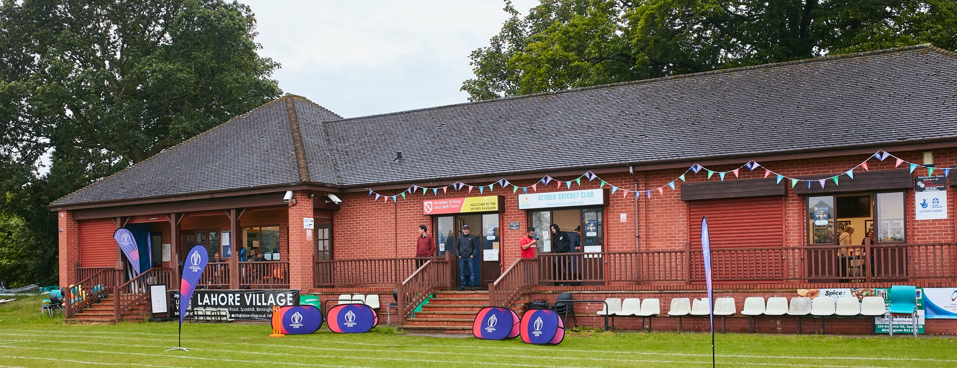

RISK ASSESSMENT FOR WEM CRICKET CLUB APRIL 2021

What are the hazards? |  | Transmission of COVID-19
Who might be harmed? |  | Facility users, staff, volunteers, opposition visitors and the wider community
No | Controls required |  | Action Taken by the Club
People Management and Communication
 | Self-screening of individuals before they arrive at the venue to ensure individuals displaying COVID-19 symptoms do not travel or attend. |  | Any player/scorer/umpire must not travel if they have been instructed to self- isolate or believe they have symptoms of Covid-19. They must report their symptoms to the Head of Cricket or Chairman immediately. All cricket associated participants have been instructed not to attend if showing any Covid-19 symptoms. Players, volunteers and match day personnel are strongly encouraged to take a twice weekly lateral flow test now freely available as advised by the Government, for self-screening purposes.  Players and supporters to travel to and from games in line with Government Guidance
 | An assessment of user numbers, space capacities, venue circulation and layout planning to maintain social distancing. |  | In line with Government plans and ECB protocols the Vice- Chairman and Head of House have updated the procedures for training, match day hospitality and use of facilities during the week. A one way system is in place for entry and exit to the toilets and playing area.
 | A plan for where parents and players will sit whilst watching cricket activities. |  | Separate, segregated areas have been set up for players (Home and Away), umpires, scorers, all visitors and spectators. Signage is in place to clearly communicate these areas.
 | Signage and communication so that all participants and visitors are aware of the control measures in place and how to act appropriately to minimise the risk of transmission of COVID-19. |  | Guidelines have been written and communicated for all players, officials, visitors and spectators when attending the facilities on Covid-19 measures.  These will also be communicated via the website and sent to all visiting teams ahead of any games played.  Signage is posted throughout and around the premises on government, club guidelines and procedures in place.
 | Staff and volunteer training to support the implementation of the plan, with suitable training records. |  | The General Committee of the club will ensure all staff & volunteers are aware of the Government guidelines and adhere to the control measures in place. Procedures have been written and are available on site in separate folder.
These procedures will be reviewed in line with the next stages of the roadmap for 17th May and then on 23rd June

Buildings
 | Assess ventilation in your building (natural and mechanical) and take appropriate measures to maximise ventilation and minimise risk of transmission. |  | The clubhouse is not currently open to the public, only for serving purposes. All windows and doors will remain open to aid the flow of air through the clubhouse.  There is no air conditioning – the changing rooms will not be in use.
 | Assess the maximum occupancy of your rooms at 2m social distancing (or 1m with risk mitigation where 2m is not possible) and establish a suitable circulation system/one-way system. Use signage and floor markings to communicate this. |  | When open the clubhouse can accommodate 36 sitting individuals maintaining safe distancing whilst the circulation system is in place. (6 x 6 set up seating areas) plus four staff, with floor markings in place.  A one-way system is clearly marked within the clubhouse to the toilets. In through the away changing room and out through the home changing rooms. Entrance and exits clearly marked.
 | Assess the arrangement of seating areas to maintain social distancing and minimise the risk of transmission. |  | Outside - Seating area set up outside with social distancing in place 2m apart for six people or two households. Table service only. No one goes to the bar or inside. Maximum capacity 54 in the covered area.  Separate seating arrangements have been set up inside when allowed to reopen (as above). Again table service only.
 | Consider your wet weather plans and describe what actions you will take to maintain social distancing in wet weather. |  | On match days the covered area outside can be used by spectators and visitors to maximum capacity. Umpires and officials included in this number. Currently  all players and visitors will return to their cars for rain interuptions.  A maximum of 40 no can be accommodated in the clubhouse for non-match day activities WHEN ALLOWED TO RE-OPEN.
Social and Hospitality Areas
 | Plan to solicit and maintain records of your member attendance, customers and visitors - to be maintained for 21 days and then destroyed. |  | Captain will sign team in on match days. Players and officials details will be taken from Play Cricket.  Contact details of any other members, visitors who attend the premises will be recorded in the registration book/QR Code.
 | Identification of suitable areas for outdoor service that don’t overlap with cricket activity. |  | N/A
 | Steps taken to minimise time and the number of people at the bar. |  | No one allowed at the bar – table service only. Everyone will remain outside until review date. Currently no use of pavilion on match days.
 | Steps taken to minimise contact points at payment or around the hospitality space. |  | Table service only. Stay seated in hospitality area in line with seating layout and social distancing. Customers to set up “tabs on account” – make only one payment by Cash or Card at the end of their stay.
 | Suitable PPE provision and training for staff and volunteers. |  | PPE equipment will be used as supplied by the club as instructed in the procedures. Masks to be used when serving.
 | Strategy for the safe serving, clearing and cleaning of glassware and tableware. |  | Covered outside area to hold 54 visitors has been set up. Table service only. Drinks, empties and glasses all collected, not refilled. Glasses washed after use – glass washer in use.  All customers can also deposit their empty cans and bottles directly into the recycle waste bins provided. Only bar servicing staff are allowed in the pavilion.
 | Deep cleaning strategy to minimise COVID-19 transmission risk |  | The pavilion and its facilities were deep cleaned on 12th April. Will not be open to the public until next of road map at which point through deep clean will take place.  Facilities cleaned at least once per week.
 | Daily cleaning strategy to minimise COVID-19 transmission risk. |  | The clubhouse and outside area will be cleaned with the appropriate cleansing materials following each time it is used.  All tables cleaned after use by group and at close and opening.
 | High-frequency touchpoint cleaning strategy to minimise COVID-19 transmission risk and how you will keep records. |  | Cleaning monitor has been set up for the bar area, all touch points and toilets. Checked on a regular basis.
These procedures will be reviewed in line with the next stages of the roadmap for 17th May and then on 23rd June

Hygiene and Cleaning
 | Materials, PPE and training that you have provided to your staff for effective cleaning. |  | PPE and all materials have been purchased and are readily available. Cleaning and bar procedures have written and all the team trained.
 | Provision of hand washing facilities with warm water, soap, disposable towels and bin. |  | Hand washing facilities are available within the toilets for all visitors and Kitchen area for bar staff.
 | Provision of suitable hand sanitiser in locations around the facility to maintain frequent hand sanitisation. |  | In addition hand sanitizers are sited at the clubhouse entrance, toilet entrances and throughout the clubhouse and outside – clearly signed.
 | Provision of suitable wipes and hand sanitiser on the field for hygiene breaks. |  | All players will be required to provide their own sanitizer/wipes as stated in the ECB guidance. In addition a sanitising station will be available in the players area and on the field of play for sanitizing breaks.
 | What are the hazards? | Other venue hazards to be considered after temporary closure such as Legionnaire’s Disease, fire, electrical safety etc.
 | Who might be harmed? | Facility users, staff, volunteers and visitors
 | Controls required |  | Action Taken by the Club
Preparing Your Buildings
 | Consider the risk of Legionnaire’s disease and carry out necessary work to make your water supply safe for users. Refer to the specific guidance in the document above. |  | Water within the clubhouse has been run through the closed season.  Appropriate check will be made for showers when back in use.
 | Check that routine maintenance has not been missed and certification is up to date (e.g. Gas safety, Electrical Safety and Portable Appliance Testing, Fire Safety, Lifts and Heating – Ventilation and Air Conditioning). |  | All appliances are certified and checked. Emergency lighting has been replaced.  Over the winter new radiators have been installed and changing rooms redecorated.
 | Check that your ground is ready and safe to play. Look at what work is required and how this can be done safely at a social distance. |  | Ground and surrounding area has been worked on regularly throughout the period and ready for play.
 | What are the hazards? | Vital first aid equipment is not available when needed. First aiders do not have adequate PPE to carry out first aid when required.
 | Who might be harmed? | First aiders, facility users, staff, volunteers and visitors
 | Controls required |  | Action Taken by the Club
First Aid and Safeguarding
 | Check that your first aid kits are stocked and accessible during all activity. |  | First aid kits will be sited in full view and accessible within the clubhouse.  The kit is new and well stocked.  First aid kit will be available in the players area.  Away changing room will be made available for any player or visitor who may be taken ill.
 | What steps have you taken to improve your first aiders’ understanding of first aid provision under COVID-19? |  | First aiders will be supplied with gloves and face mask which will be sited adjacent to the first aid kit.  Appropriate training is in hand.
 | If you have an AED then check that it is in working order, service is up to date and that it is available during all activity. |  | AFD is on order and has been checked.
 | DBS checks and Safehands |  | All is in place and necessary actions taken as appropriate to update system by Child Welfare Officer
 | What are the hazards? | Pitches, practice facilities or outfield are unsafe to play on
 | Who might be harmed? | Players, officials, ground staff
 | Controls required |  | Action Taken by the Club
Preparing your Grounds and Outside facilities
 | Safety checks on machinery, sightscreens and covers. |  | All continually checked and machinery has been used extensively since March.  New equipment shed was erected in April 2020
 | Check and repair of any damage to pitches and outfields. |  | All well maintained and ready for use. Wicket preparation well ahead. Outfield cut twice per week.
 | Surfaces checked and watering regime adjusted based on lack of rainfall. |  | All well maintained and ready for use.
 | Practice sessions and nets |  | For seniors - three nets available – two artificial and one grass. Only work in organised groups of six by cricket Manager. Training nights pre-season Tuesday and Thursday. During Season Wednesday.  Woman and Girls – training starts Friday 23rd April – format as above  Juniors – split into two sessions each Thursday 6.00 – 7.00 – 7.00 to 8.00 starts 22nd April – Registration and starter session. Programme starts thereafter in line with training guidelines.  All Stars - starts in May – Tuesday nights – in line with prescribed programme.  Greeter/Meeter in place from the committee each week for point of contact for any COVID 19 or general queries.
 | What are the hazards? | Access to the ground and playing area by the general public
 | Who might be harmed? | Damage to the playing area and safety of the general public
 | Controls required |  | Action Taken by the Club
 | Safety for visitors during play and general public getting onto the playing area. |  | New fencing has been erected around the entrance to the ground for better protection and security
 | Route for Dog walkers and public safety |  | Clear signage for public right of way around the ground. Dogs to be kept on leads and

