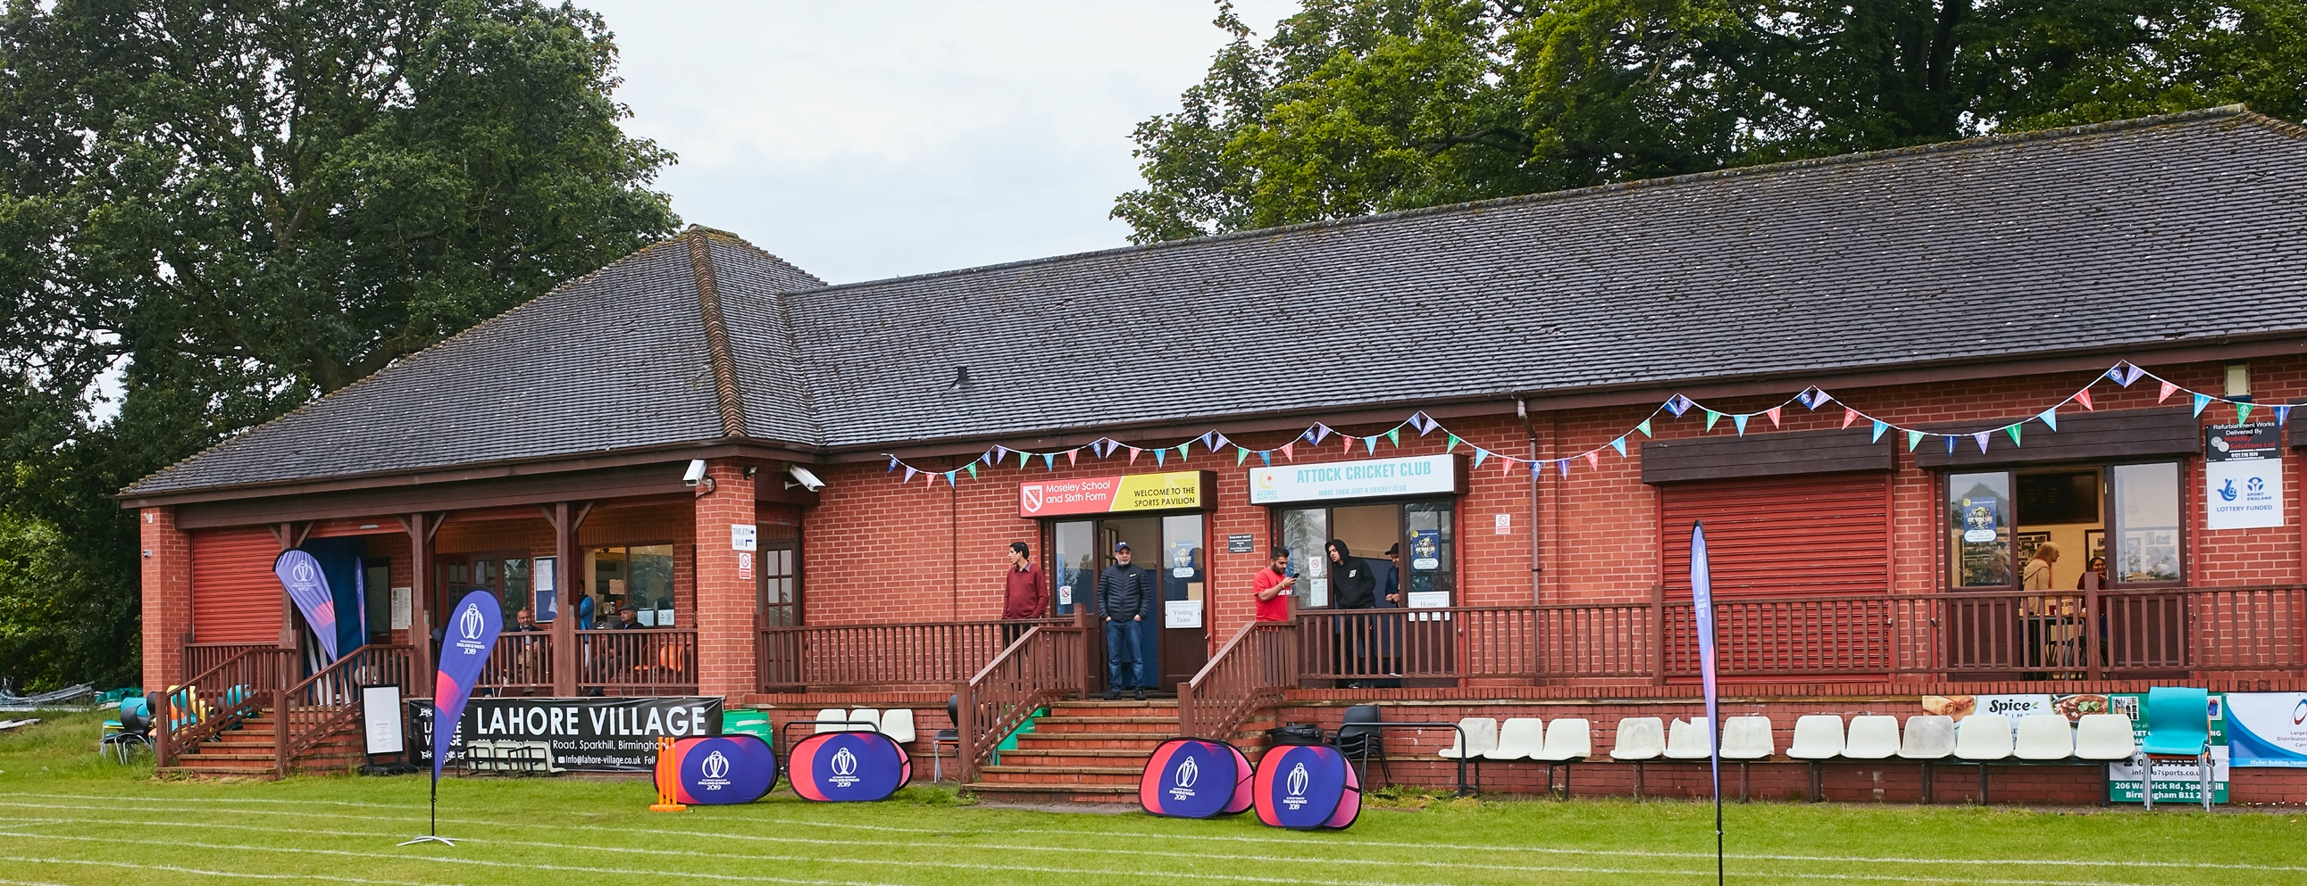

RISK ASSESSMENT TEMPLATE FOR CLUBS PREPARING TO OPEN THEIR FACILITIES & CLUBHOUSE IN WALES

Risk Assessment Template
As a facility provider, you should complete your own COVID-19 Risk Assessment and publish this to your users.

If you are not the facility provider, then you should consider which sections will apply to your clubs individual situation upon returning to play and complete a risk assessment based on your activity, including (but not limited to) people management and communication, hygiene and first aid. You may still wish to record that you have assessed facility risks through enquiries made with your facility provider.

We have provided an example risk assessment below, which is for illustrative purposes only, and includes some examples of things to consider. Consider how this will apply to each aspect of your operation and identify the controls you require to meet Welsh Government guidance regarding health, social distancing and hygiene etc. Remember that you must review your other Health and Safety, and Safeguarding, risk assessments for other hazards such as fire, first aid etc.

What are the hazards? |  | Transmission of COVID-19
Who might be harmed? |  | Facility users, staff, volunteers, visitors and the wider community
No | Controls required |  | Action Taken by the Club
People Management and Communication
 | Self-screening of individuals before they arrive at the venue to ensure individuals displaying COVID-19 symptoms or those who should be shielding do not travel or attend. |  | Make the selected team aware that if they display COVID symptoms they must not attend the ground.
 | An assessment of user numbers, space capacities, venue circulation and layout planning to maintain social distancing. |  | The clubhouse will remain closed. We will operate a one way system round the back of the pavilion to the toilets. The car park is of ample size to maintain distancing.
 | A plan for where parents and players will sit whilst watching cricket activities. |  | There is a large area in front of the pavilion where distancing can be maintained. The boundary rope will be brought in, if needed, to enlarge this area.
 | Signage and communication so that all participants and visitors are aware of the control measures in place and how to act appropriately to minimise the risk of transmission of COVID-19. |  | Signage to illustrate the one way system around the pavilion to the toilets and a reminder to maintain social distancing.
 | Staff and volunteer training to support the implementation of the plan, with suitable training records. |  | Tom Lea – First XI Captain and Duncan Wright - CWO
Buildings
 | Assess ventilation in your building (natural and mechanical) and take appropriate measures to maximise ventilation and minimise risk of transmission. |  | The pavilion will remain closed. Windows to be opened to provide ventilation in case of an emergency.
 | Assess the maximum occupancy of your rooms at 2m social distancing and establish a suitable circulation system/one-way system. Use signage and floor markings to communicate this. |  | The pavilion will remain closed. Toilets are one in one out.
 | Assess the arrangement of seating areas to maintain social distancing and minimise the risk of transmission. |  | The pavilion will remain closed.
 | Consider your wet weather plans and describe what actions you will take to maintain social distancing in wet weather. |  | There is a porch where people can shelter. If full, people will be asked to return to their cars if rain happens.
Social and Hospitality Areas
 | Plan to solicit and maintain records of your member attendance, customers and visitors - to be maintained for 21 days and then destroyed. |  | Spectators will be banned until further notice. A register will be taken off any spectators when they are allowed including phone numbers, and then will be destroyed after the 21 day period.
 | Identification of suitable areas for outdoor service that don’t overlap with cricket activity. |  | N/A
 | Steps taken to minimise time and the number of people at the bar. |  | N/A
 | Steps taken to minimise contact points at payment or around the hospitality space. |  | N/A
 | Suitable PPE provision and training for staff and volunteers. |  | N/A
 | Strategy for the safe serving, clearing and cleaning of glassware and tableware. |  | N/A
 | Deep cleaning strategy to minimise COVID-19 transmission risk. |  | Deep clean to be implemented prior to use of the club.
 | Daily cleaning strategy to minimise COVID-19 transmission risk. |  | Club is only in use one day every week maximum. It will be cleaned before every use.
 | High-frequency touchpoint cleaning strategy to minimise COVID-19 transmission risk and how you will keep records. |  | High touch point areas include toilet door, toilet flush and sink taps. Club will implement a cleaning process before, during (mid-innings break) and after the match. A sign off sheet will be placed in each toilet and signed once complete.
Hygiene and Cleaning
 | Materials, PPE and training that you have provided to your staff for effective cleaning. |  | Masks and gloves
 | Provision of hand washing facilities with warm water, soap, disposable towels and bin. |  | Hand sanitizer will be available in the toilets, with disposable towels.
 | Provision of suitable hand sanitiser in locations around the facility to maintain frequent hand sanitisation. |  | Hand sanitizer will be available in front of the pavilion.
 | Provision of suitable wipes and hand sanitiser on the field for hygiene breaks. |  | Wipes and hand sanitizer available for hygiene breaks.
 | What are the hazards? | Other venue hazards to be considered after temporary closure such as Legionnaire’s Disease, fire, electrical safety etc.
 | Who might be harmed? | Facility users, staff, volunteers and visitors
 | Controls required |  | Action Taken by the Club
Preparing Your Buildings
 | Consider the risk of Legionnaire’s disease and carry out necessary work to make your water supply safe for users. Refer to the specific guidance in the document above. |  | We have no hot water tanks.
 | Check that routine maintenance has not been missed and certification is up to date (e.g. Gas safety, Electrical Safety and Portable Appliance Testing, Fire Safety, Lifts and Heating – Ventilation and Air Conditioning). |  | Certification is up to date.
 | Check that your ground is ready and safe to play. Look at what work is required and how this can be done safely at a social distance. |  | Grounds people have been working maintaining social distance.
 | What are the hazards? | Vital first aid equipment is not available when needed. First aiders do not have adequate PPE to carry out first aid when required.
 | Who might be harmed? | First aiders, facility users, staff, volunteers and visitors
 | Controls required |  | Action Taken by the Club
First Aid
 | Check that your first aid kits are stocked and accessible during all activity. |  | First Aid Kit is available and fully stocked in the pavilion. This is the only time someone may enter the pavilion.
 | What steps have you taken to improve your first aiders’ understanding of first aid provision under COVID-19? |  | First aiders will be forwarded the latest St Johns Ambulance, as recommended by the ECB, guidance on dealing with first aid during Covid-19.
 | If you have an AED then check that it is in working order, service is up to date and that it is available during all activity. |  | N/A
 | What are the hazards? | Pitches or outfield are unsafe to play on
 | Who might be harmed? | Players, officials, ground staff
 | Controls required |  | Action Taken by the Club
Preparing your Grounds
 | Safety checks on machinery, sightscreens and covers. |  | All equipment is checked regularly by our groundsman.
 | Check and repair of any damage to pitches and outfields. |  | Will be checked and repaired and out groundsman before any games.
 | Surfaces checked and watering regime adjusted based on lack of rainfall. |  | Will be administered by our groundsman.
 | What are the hazards? | Spectators touching the ball
 | Who might be harmed? | Spectators and then players
 | Controls required |  | Action Taken by the Club
 | Identify your own control measures required. |  | Spectators should be advised not to touch the ball with their hands

 | What are the hazards? | Use this space to identify hazards at your venue
 | Who might be harmed? | Use this space to identify who might be harmed
 | Controls required |  | Action Taken by the Club
 | Identify your own control measures required.

 | What are the hazards? | Use this space to identify hazards at your venue
 | Who might be harmed? | Use this space to identify who might be harmed
 | Controls required |  | Action Taken by the Club
 | Identify your own control measures required.

PLEASE SEE MAIN INFOGRAPHIC BELOW & ON THESE LINKS
8 step plan Before During & After Main Guidance
