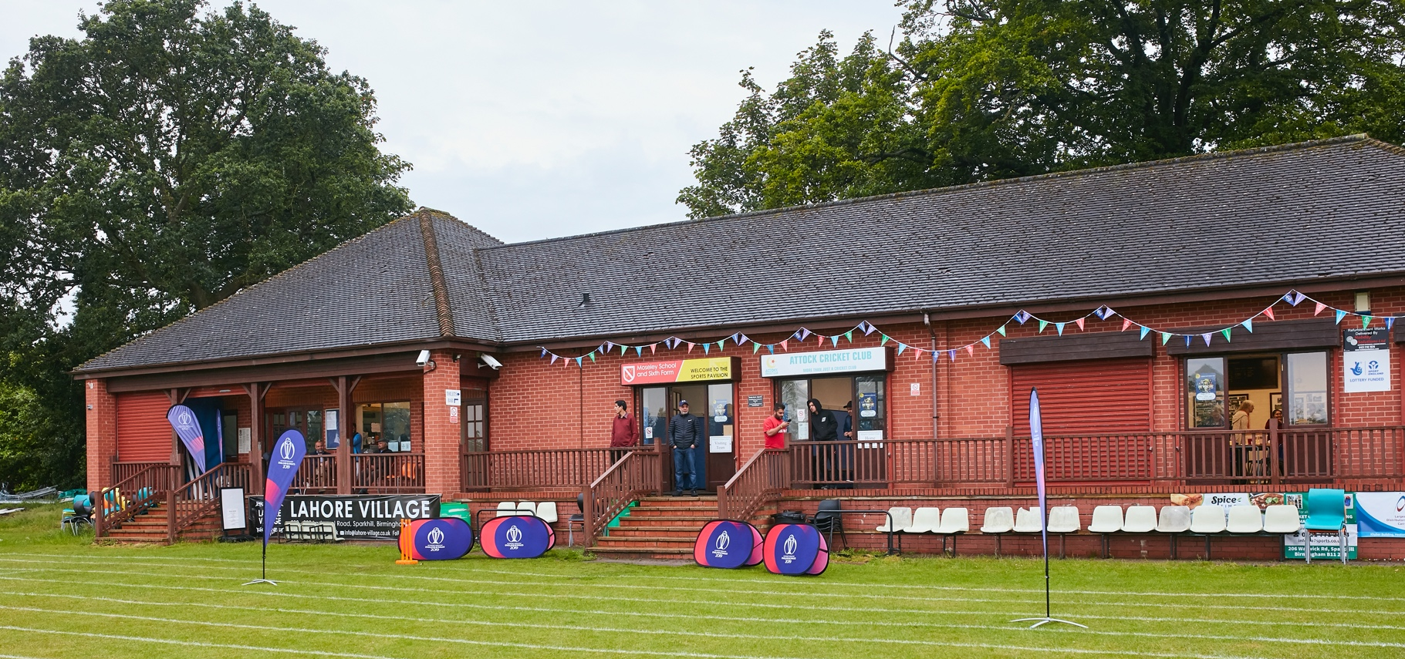

ACTION CHECKLIST FOR BISHOPS CASTLE CC PREPARING TO GET THEIR CLUBHOUSE READY - 2021

No | Action | Completed
1 | Preparation
1.1 | Have you read the government guidance on social distancing after 4th July 2020, available here?
1.2 | Have you read and understood the ECB Return to Play Guidance available?  NOTE THIS WILL BE MADE AVAILABLE ONCE STEP 4 IS PERMITTED
1.3 | Have you read and understood the ECB Getting your Pavilion and Grounds Ready for Step 4 guidance (this document)?
1.4 | Have you completed your COVID-19 Risk Assessment and shared this with your participants? (See Appendix)
1.5 | Have you shared your operation plan and COVID-19 Risk Assessment with your insurer and insurance adviser?
2 | On your Ground
2.1 | Have you referred to the latest GMA Guidance on grounds maintenance during COVID-19 available here?
2.2 | Have you checked that your machinery, sightscreens and covers are in good, safe working order and their service requirements are up to date? Document this in your COVID-19 risk assessment.
2.3 | Have you checked the condition of your square, outfield and non-turf facilities (including nets) and repaired any damage to make these safe for return to play?
2.4 | Is your grass at the right cut height? If not, adjust now.
2.5 | Have you applied enough water to allow pitches to be prepared safely? Refer to the GMA guidance.
3 | People Management and Communication
3.1 | Have you planned how to ensure that visitors are aware that they must screen themselves for COVID-19 symptoms before coming to your venue and should not leave their homes if they are displaying symptoms? Have you communicated and facilitated that process?
3.2 | Have you assessed the different user groups (participants), their numbers and needs and developed a plan to move them to, within and from your venue safely?
3.3 | Have you assessed the time that different user groups will spend at the venue and managed the risk accordingly?
3.4 | Have you developed a communication plan?
3.5 | Have you tailored this to different user groups and adapted for young people or those with a disability? | (subject to capacity)
3.6 | Have you used all your communication channels to reach different people effectively (social media, email, website etc)?
3.7 | Have you corresponded with your league (where applicable) and opposition to let them know your COVID-19 plans and how they need to act when they are at your venue?
3.8 | Have you developed your signage, thought about where signage is needed and produced this in a way that does not create a touchpoint?
3.9 | Have you carried out briefings with your employees, contractors and volunteers and kept records to show that this has been understood and an opportunity to have questions answered has been given?
3.10 | Have you made sure that players, match officials and parents are aware that participants should arrive and leave in match or training kit?
4 | In your Buildings
4.1 | Have you carried out the necessary checks and actions to manage the risk of Legionella? See the guidance from the HSE here.
4.2 | Have you maximised ventilation by opening windows and doors (not fire doors)?
4.3 | If you have an air conditioning system, has it been set to exchange with external air and not recirculate? | NA
4.4 | Have you checked that routine maintenance has not been missed and certification is up to date (e.g. Gas safety, Electrical Safety and Portable Appliance Testing, Fire Safety, Lifts and Heating – Ventilation and Air Conditioning)?
4.5 | If services were isolated – have they been reinstated by a qualified professional?
4.6 | Have you assessed the maximum occupancy of your rooms at 2m and 1m+ social distancing, and established a suitable circulation system / one-way system? | (Toilets)
4.7 | Have you used signage and floor markings to communicate this?
4.8 | Have you arranged your seating avoiding face-to-face arrangements?
4.9 | Have you considered how your scorebox can be used safely? | (One person)
4.10 | Have you got a plan for what you are going to do in wet weather (use personal vehicles, use temporary structures like gazebos and marquees etc)? Have you communicated this plan? | (See Risk Assessment)
5 | Social and Hospitality
5.1 | Have you read and understood the government guidance and checklist available here? | NA
5.2 | Have you read and understood the guidance from the Food Standards Agency available here? | NA
5.3 | Have you reviewed your food hygiene and safety procedures and carried out any post lockdown cleaning and monitoring as required? | NA
5.4 | Have you identified suitable areas for outdoor service and can you ensure these don’t overlap with team / parent areas? | NA
5.5 | Have you got a plan to circulate people between areas whilst maintaining social distancing? | (One-Way)
5.6 | Have you got suitable signage, guideline notices and other methods to communicate this? | NA
5.7 | Have you removed bar stools etc and put up notices reminding patrons that time at the bar should be minimised? | NA
5.8 | Do you have Contactless payment methods? If not, could you use Contactless payment at your venue? | NA
5.9 | Do you have online menus? | NA
5.10 | Can you set up online ordering? Or a text message system? | NA
5.11 | Have you removed touchpoints (no cutlery or condiments on tables or stations – serve with food; no beer mats or tablecloths)? | NA
5.12 | Have you provided suitable PPE for staff/volunteers working?
5.13 | Have you trained those volunteers on hygiene, 1m+ social distancing requirements and risk mitigation such as picking glasses up at the base not the rim, using a fresh glass with each drink, etc.? | NA
5.14 | Are your dishwasher and glasswasher serviced and able to operate at high temperatures? | NA
5.15 | Do you have a strategy for preventing glass breakages on the playing areas? | NA
5.16 | Whilst disposable tableware and glassware are an option, have you considered more sustainable options? | NA
5.17 | Do you have a system for collecting temporary (held for 21 days) contact records of your members/ visitors/ customers to supply to NHS Test and Trace if required?
6 | Cleaning and Hygiene
6.1 | Have you carried out a thorough clean of all areas, all surfaces and all potential contact points before opening?
6.2 | Have you got a toilet checking and cleaning programme in place?
6.3 | Have you got signage on handwashing technique and have you provided soap for hand washing?
6.4 | Have you assessed handwashing queues and whether or not suitable hand sanitiser can be provided to support this?
6.5 | Have you assessed optimum locations for hand sanitiser stations and where these should be located?
6.6 | Have you assessed the quantities of hand sanitiser required (anticipate for Day 1, review for Day 2 and so on) and purchased enough to maintain supply?
6.7 | Have you supplied suitable cleaning wipes and hand sanitiser for the field of play and have you instructed match officials to provide suitable hygiene breaks?
6.8 | Have you planned to carry out an all surface clean daily pre and post-opening? | (Matchdays only)
6.9 | Have you identified common touch points (such as door handles, gaming machines, sanitiser stations) and developed a plan to clean these frequently (e.g. hourly)?
6.10 | Have you trained your staff, provided suitable materials and PPE to clean down tables after each customer group leaves?
6.11 | Have you provided suitable training, materials and PPE for your staff or volunteers to carry out cleaning to your plan?
6.12 | Although changing rooms are not in use, are you still maintaining cleaning and regular maintenance to maintain safety, particularly if the changing room is to be used in an emergency or as an isolation room for suspected COVID-19 cases?
7 | PPE and First Aid
7.1 | Have you made sure that your first aiders have reviewed the advice provided by St John Ambulance on first aid during the COVID-19 pandemic – available here.
7.2 | Have you checked that your first aid kits are stocked, in-date and available during activities?
7.3 | Have you assessed the PPE (including face coverings) required by your first aiders and made that available in/with the first aid kits?
7.4 | Have you checked that your Automated External Defibrillators (AEDs) are working, serviced and available during activities? | NA
7.5 | Have you assessed the requirement to supply / wear face coverings under any 1m+ social distancing requirements in your buildings? | NA
7.6 | Have you made and communicated a plan on what to do if someone develops COVID-19 symptoms at your venue? | (Test & Trace)

Having reviewed your checklist, you should complete your COVID-19 risk assessment to record your assessment of risk and the actions you have taken to reduce these risks in compliance with the legislation and guidance. Append the completed check list to your COVID-19 risk assessment.

