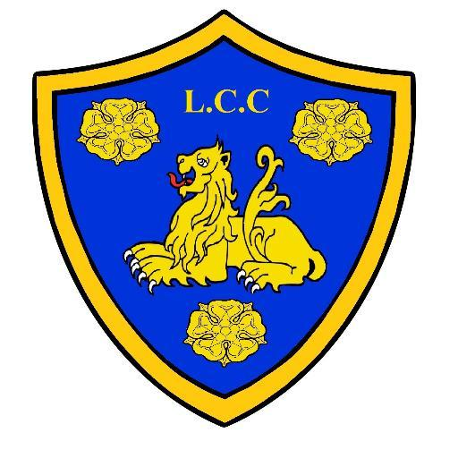
Ludlow Cricket Club
CLUB HOUSE
NEW COVID regulations
Risk Assessment overview
(ALL VISTORS and MEMBERS please read)
Updated 17/05/2021

As members and players, we ALL need to play our part in keeping the facilities and venue safe and accessible for all.
We have put in place some basic structure to the use of facilities on match and training days.
The Clubhouse plays a big part of the Cricket experience and we have worked hard as a Committee to make the new regulations work for Our Club.
A deep clean and lots of planning has gone into making the use of the facility possible.
Please help us to make this work and we can continue to use and enjoy our facility.

BAR AREA
- Drinks will be ordered from bar (Perspex screen in operation)
- RULE OF 6 to be ADHERED to, in the INDOOR SEATING area
- Track and trace in operation OR a contact form will be in use as you enter the Bar area (1 per family, per visit) -Times and dates of visit and contact details.
- Follow the distancing floor markings.
- Cashless CARD payments only (if possible)
- NO standing in the bar area. Please be seated at tables.
- Wear masks to visit Bar or Visit the Toilet.

- Disposable cups will be used where possible.
- Hand sanitizers available
- Increased cleaning in operation throughout the day.
- Masks if social distancing cannot be adhered to.
TOILETS
- One IN/One OUT
- Ladies- lock on the outer door from now on.
- Hand sanitizer available on entrance and exit.

SPECTATORS
- Please bring your own spectator’s chair to assist social distancing around the ground
- No touching the playing ball, boundary rope/machine or other equipment.
- Government ‘social distancing’ guidance.
- Please be aware of the ECB ‘Road Map’ guidance for spectators.

OUR CLUB, OUR RESONSIBILITY.
LET’S PLAY AND ENJOY CRICKET AGAIN
Thank you for your continued support.
LCC Committee.

