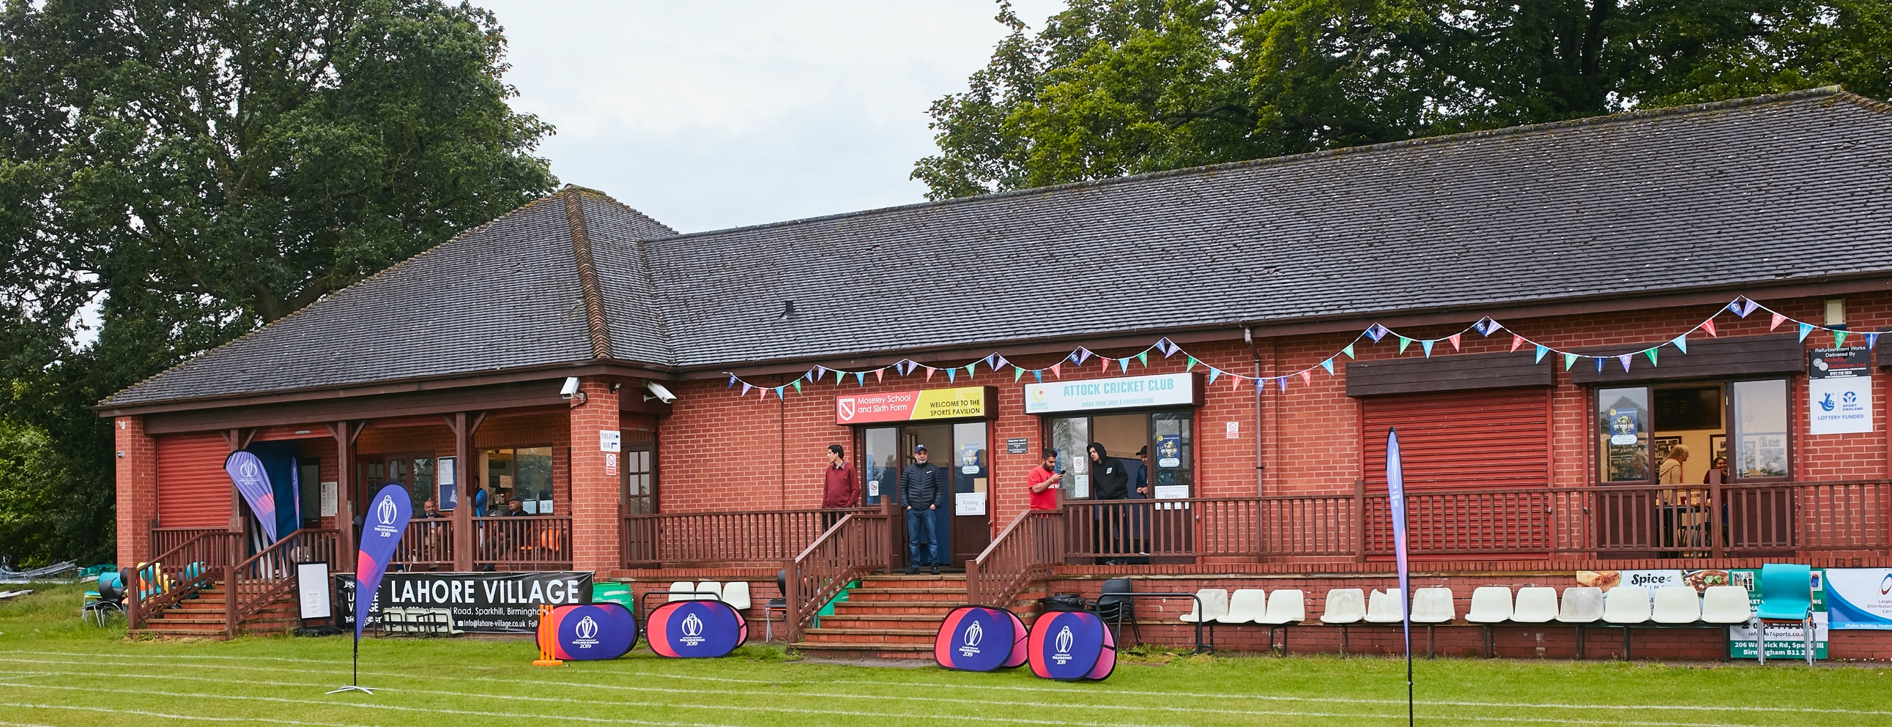

RISK ASSESSMENT TEMPLATE FOR CLUBS PREPARING TO OPEN THEIR CLUBHOUSE

Risk Assessment Template
As a facility provider, you should complete your own COVID-19 Risk Assessment and publish this to your users.

If you are not the facility provider, then you should consider which sections will apply to your clubs individual situation upon returning to play and complete a risk assessment based on your activity, including (but not limited to) people management and communication, hygiene and first aid. You may still wish to record that you have assessed facility risks through enquiries made with your facility provider.

We have provided an example risk assessment below, which is for illustrative purposes only, and includes some examples of things to consider. Consider how this will apply to each aspect of your operation and identify the controls you require to meet Government guidance regarding health, social distancing and hygiene etc. Remember that you must review your other Health and Safety, and Safeguarding, risk assessments for other hazards such as fire, first aid etc.

What are the hazards? |  | Transmission of COVID-19
Who might be harmed? |  | Facility users, staff, volunteers, visitors and the wider community
No | Controls required |  | Action Taken by the Club
People Management and Communication
1 | Self-screening of individuals before they arrive at the venue to ensure individuals displaying COVID-19 symptoms or those who should be shielding do not travel or attend. |  | All players briefed not to attend if feeling unwell. Signage on arrival to home ground to reinforce the message for visitors.
2 | An assessment of user numbers, space capacities, venue circulation and layout planning to maintain social distancing. |  | Only the toilets will be in use – one person occupancy at any one time. One person at a time in the scorebox. The pavilion will not be open for any other purpose.
3 | A plan for where parents and players will sit whilst watching cricket activities. |  | Players, officials and spectators who are not on the field will be spaced appropriately around the boundary.
4 | Signage and communication so that all participants and visitors are aware of the control measures in place and how to act appropriately to minimise the risk of transmission of COVID-19. |  | Signs have been placed to be visible to players and spectators outside the building
5 | Staff and volunteer training to support the implementation of the plan, with suitable training records. |  | The risk assessment was reviewed by the Committee before the commencement of the 2021 season to check it was still fit for purpose.
Buildings
6 | Assess ventilation in your building (natural and mechanical) and take appropriate measures to maximise ventilation and minimise risk of transmission. |  | There is an external window in the gent’s toilet. The scorebox is well ventilated. There is no external ventilation to the ladies’ toilet – safe occupancy levels (one person at a time) and hand-wash posters highly visible to reduce risk of transmission.
7 | Assess the maximum occupancy of your rooms at 2m social distancing (or 1m with risk mitigation where 2m is not possible) and establish a suitable circulation system/one-way system. Use signage and floor markings to communicate this. |  | The clubhouse, changing room and showers are closed. Access to toilets is via separate rear door, with access for one person at a time. Signage is in place
8 | Assess the arrangement of seating areas to maintain social distancing and minimise the risk of transmission. |  | External only. Players advised to bring own chairs and to sit two metres apart
9 | Consider your wet weather plans and describe what actions you will take to maintain social distancing in wet weather. |  | Players will return to their own cars pending a decision about match resumption
Social and Hospitality Areas
10 | Plan to solicit and maintain records of your member attendance, customers and visitors - to be maintained for 21 days and then destroyed. |  | Captain will record all attendees, including umpires, scorers and supporters and will retain for 21 days,
11 | Identification of suitable areas for outdoor service that don’t overlap with cricket activity. |  | NONE
12 | Steps taken to minimise time and the number of people at the bar. |  | Not applicable
13 | Steps taken to minimise contact points at payment or around the hospitality space. |  | Not applicable
14 | Suitable PPE provision and training for staff and volunteers. |  | The groundsman has his own PPE and there are no other staff or volunteers
15 | Strategy for the safe serving, clearing and cleaning of glassware and tableware. |  | Not applicable
16 | Deep cleaning strategy to minimise COVID-19 transmission risk |  | A contract cleaner cleans the pavilion and toilets, and all areas are deep cleaned after use in accordance with the requirements of the Playing Fields Association
17 | Daily cleaning strategy to minimise COVID-19 transmission risk. |  | The pavilion is closed except for the use of the toilets during matches, which are cleaned before and after use.
18 | High-frequency touchpoint cleaning strategy to minimise COVID-19 transmission risk and how you will keep records. |  | The Playing Fields Association organize and control the cleaning, and keep appropriate records.
Hygiene and Cleaning
19 | Materials, PPE and training that you have provided to your staff for effective cleaning. |  | We do not have staff. The groundsman has his own PPE and has studied the relevant regulations related to its use.
20 | Provision of hand washing facilities with warm water, soap, disposable towels and bin. |  | Warm water, soap, disposable towels and a bin with a lid are available in the toilets
21 | Provision of suitable hand sanitiser in locations around the facility to maintain frequent hand sanitisation. |  | Hand sanitizer is available in the lobby outside the toilet, the players are advised also to bring their own, and the club has a supply available on match days
22 | Provision of suitable wipes and hand sanitiser on the field for hygiene breaks. |  | These are available on the field and on the verandah outside the pavilion.
 | What are the hazards? | Other venue hazards to be considered after temporary closure such as Legionnaire’s Disease, fire, electrical safety etc.
 | Who might be harmed? | Facility users, staff, volunteers and visitors
 | Controls required |  | Action Taken by the Club
Preparing Your Buildings
23 | Consider the risk of Legionnaire’s disease and carry out necessary work to make your water supply safe for users. Refer to the specific guidance in the document above. |  | We do not own the building. The Playing Fields Association is responsible for the testing, and the water is run regularly in accordance with Legionella prevention protocols.
24 | Check that routine maintenance has not been missed and certification is up to date (e.g. Gas safety, Electrical Safety and Portable Appliance Testing, Fire Safety, Lifts and Heating – Ventilation and Air Conditioning). |  | The routine maintenance is all up to date and under the control of the PFA.
25 | Check that your ground is ready and safe to play. Look at what work is required and how this can be done safely at a social distance. |  | The ground has been fully maintained over the winter and throughout lockdown, and also in accordance with social distancing measures
 | What are the hazards? | Vital first aid equipment is not available when needed. First aiders do not have adequate PPE to carry out first aid when required.
 | Who might be harmed? | First aiders, facility users, staff, volunteers and visitors
 | Controls required |  | Action Taken by the Club
First Aid
26 | Check that your first aid kits are stocked and accessible during all activity. |  | The first aid kit is fully stocked and up to date and fully accessible during activity.
27 | What steps have you taken to improve your first aiders’ understanding of first aid provision under COVID-19? |  | There is a nominated First Aider who has been made aware of Covid 19 First Aid protocols.
28 | If you have an AED then check that it is in working order, service is up to date and that it is available during all activity. |  | Not applicable
 | What are the hazards? | Pitches or outfield are unsafe to play on
 | Who might be harmed? | Players, officials, ground staff
 | Controls required |  | Action Taken by the Club
Preparing your Grounds
29 | Safety checks on machinery, sightscreens and covers. |  | Checks have been carried out and are up to date, All machinery has been serviced
30 | Check and repair of any damage to pitches and outfields. |  | This has been checked and there is no damage
31 | Surfaces checked and watering regime adjusted based on lack of rainfall. |  | There has been sufficient rainfall. The ground is in good condition.
 | What are the hazards? | Lack of awareness of procedures at the ground
 | Who might be harmed? | All players and spectators
 | Controls required |  | Action Taken by the Club
32 | Regulations for young cricketers |  | There is full communication with the parent or carer of any young cricketer who is selected to play to assess the awareness of the young person of the control measures in place. Visiting captain requested to ensure visiting young players are aware. There is no junior section to the club so this only applies to adult cricket.
33 | Control measures for access to toliets |  | Clear signage to inform all players and spectators of the single occupancy rule in the toilet area.
34 | Umpires to be made aware of procedures |  | Any players serving as umpires to be made aware of covid procedures and that they are not to touch the ball, and are to be solely responsible for the stumps and bails at their end, with gloves available for rearranging stumps at fall of wicket.
35 | Spectators to be made aware of regulations |  | Spectators will be directed to an appropriate viewing area and there are signs to explain distancing procedures and toilet protocols.
36 | Safety procedures for scorebox and scoring equipment. |  | One person in the scorebox at any one time. Only one person operating the scoreboard. Players and spectators informed to respect the social distancing of the scorer.
37 | Seating arrangements to comply with social distancing |  | Players and spectators required to respect the 2m social distancing around the boundary.
38 | On field equipment |  | Designated players to put out and collect in flags, discs, stumps and bails.

 | What are the hazards? | Use this space to identify hazards at your venue
 | Who might be harmed? | Use this space to identify who might be harmed
 | Controls required |  | Action Taken by the Club
 | Identify your own control measures required.

 | What are the hazards? | Use this space to identify hazards at your venue
 | Who might be harmed? | Use this space to identify who might be harmed
 | Controls required |  | Action Taken by the Club
 | Identify your own control measures required.

TRYSULL AND SEISDON CRICKET CLUB 21 APRIL 2021

