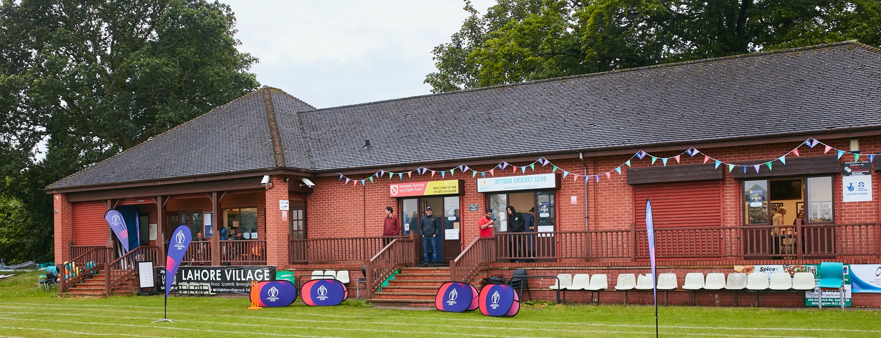

RISK ASSESSMENT TEMPLATE FOR CLUBS PREPARING TO OPEN THEIR CLUBHOUSE

Risk Assessment Template
As a facility provider, you should complete your own COVID-19 Risk Assessment and publish this to your users.

If you are not the facility provider, then you should consider which sections will apply to your clubs individual situation upon returning to play and complete a risk assessment based on your activity, including (but not limited to) people management and communication, hygiene and first aid. You may still wish to record that you have assessed facility risks through enquiries made with your facility provider.

We have provided an example risk assessment below, which is for illustrative purposes only, and includes some examples of things to consider. Consider how this will apply to each aspect of your operation and identify the controls you require to meet Government guidance regarding health, social distancing and hygiene etc. Remember that you must review your other Health and Safety, and Safeguarding, risk assessments for other hazards such as fire, first aid etc.

What are the hazards? |  | Potential viral infection – Covid-19
Who might be harmed? |  | Players, Officials, parents and other visitors, and their subsequent contacts
No | Controls required |  | Action Taken by the Club
People Management and Communication
 | Self-screening of individuals before they arrive at the venue to ensure individuals displaying COVID-19 symptoms or those who should be shielding do not travel or attend. |  | All members instructed that they should not visit club, if Covid-positive or symptomatic, or if any household member is.
 | An assessment of user numbers, space capacities, venue circulation and layout planning to maintain social distancing. |  | All activity to take place outdoors . Clubhouse and bar closed until min. May 17th. Update to follow then
 | A plan for where parents and players will sit whilst watching cricket activities. |  | Separate “players only” area designated. All other visitors to maintain social distancing
 | Signage and communication so that all participants and visitors are aware of the control measures in place and how to act appropriately to minimise the risk of transmission of COVID-19. |  | Signage and instructions on entry to designated toilets. Visiting captains briefed on arrival
 | Staff and volunteer training to support the implementation of the plan, with suitable training records. |  | All volunteers aware of rules and procedures. Staff in clubhouse will be trained before opening date.
Buildings
 | Assess ventilation in your building (natural and mechanical) and take appropriate measures to maximise ventilation and minimise risk of transmission. |  | Access to buildings for toilet use only. Ventilation measures in place for future opening date.
 | Assess the maximum occupancy of your rooms at 2m social distancing (or 1m with risk mitigation where 2m is not possible) and establish a suitable circulation system/one-way system. Use signage and floor markings to communicate this. |  | One at a time in each toilet area. Signs in place
 | Assess the arrangement of seating areas to maintain social distancing and minimise the risk of transmission. |  | Will be as 2020, when buildings are open. Reduced furniture and monitoring of numbers. Outdoor seating available
 | Consider your wet weather plans and describe what actions you will take to maintain social distancing in wet weather. |  | Return to cars . Gazebos in use but with limited capacity
Social and Hospitality Areas
 | Plan to solicit and maintain records of your member attendance, customers and visitors - to be maintained for 21 days and then destroyed. |  | Log kept of all attendance outside of matches. QR Code / Log sheet to be used on entry to building for toilets
 | Identification of suitable areas for outdoor service that don’t overlap with cricket activity. |  | Separate players area
 | Steps taken to minimise time and the number of people at the bar. |  | N/A. Arrangements to be determined according prevailing rules at the time
 | Steps taken to minimise contact points at payment or around the hospitality space. |  | N/A. Arrangements to be determined according prevailing rules at the time
 | Suitable PPE provision and training for staff and volunteers. |  | N/A. Arrangements to be determined according prevailing rules at the time
 | Strategy for the safe serving, clearing and cleaning of glassware and tableware. |  | N/A. Arrangements to be determined according prevailing rules at the time
 | Deep cleaning strategy to minimise COVID-19 transmission risk |  | Cleaning schedules before and after games. All users instructed to hand sanitise on entry and sanitise touch points. Materials provided.
 | Daily cleaning strategy to minimise COVID-19 transmission risk. |  | Currently clean areas which are in use. i.e. toilets
 | High-frequency touchpoint cleaning strategy to minimise COVID-19 transmission risk and how you will keep records. |  | Instructions for all users to clean touchpoints on each visit
Hygiene and Cleaning
 | Materials, PPE and training that you have provided to your staff for effective cleaning. |  | N/A . No staff currently
 | Provision of hand washing facilities with warm water, soap, disposable towels and bin. |  | Sanitiser, hand wipes, disinfectant spray at entry point and in each toilet
 | Provision of suitable hand sanitiser in locations around the facility to maintain frequent hand sanitisation. |  | Sanitising materials also provided for use during matches and practice
 | Provision of suitable wipes and hand sanitiser on the field for hygiene breaks. |  | As above
 | What are the hazards? | Other venue hazards to be considered after temporary closure such as Legionnaire’s Disease, fire, electrical safety etc.
 | Who might be harmed? | Facility users, staff, volunteers and visitors
 | Controls required |  | Action Taken by the Club
Preparing Your Buildings
 | Consider the risk of Legionnaire’s disease and carry out necessary work to make your water supply safe for users. Refer to the specific guidance in the document above. |  | Water supply regularly flushed
 | Check that routine maintenance has not been missed and certification is up to date (e.g. Gas safety, Electrical Safety and Portable Appliance Testing, Fire Safety, Lifts and Heating – Ventilation and Air Conditioning). |  | All routine inspections and certifications are up to date
 | Check that your ground is ready and safe to play. Look at what work is required and how this can be done safely at a social distance. |  | Prepared and safe. Regular inspections carried out.
 | What are the hazards? | Vital first aid equipment is not available when needed. First aiders do not have adequate PPE to carry out first aid when required.
 | Who might be harmed? | First aiders, facility users, staff, volunteers and visitors
 | Controls required |  | Action Taken by the Club
First Aid
 | Check that your first aid kits are stocked and accessible during all activity. |  | First aid kits at various points
 | What steps have you taken to improve your first aiders’ understanding of first aid provision under COVID-19? |  | N/A
 | If you have an AED then check that it is in working order, service is up to date and that it is available during all activity. |  | Debfibrillator mounted outdoors on wall. Always available
 | What are the hazards? | Pitches or outfield are unsafe to play on
 | Who might be harmed? | Players, officials, ground staff
 | Controls required |  | Action Taken by the Club
Preparing your Grounds
 | Safety checks on machinery, sightscreens and covers. |  | All equipment and machinery, checked, serviced and repaired as necessary
 | Check and repair of any damage to pitches and outfields. |  | Checked. OK
 | Surfaces checked and watering regime adjusted based on lack of rainfall. |  | Ongoing Checks are done
 | What are the hazards? | Infection by Covid-19
 | Who might be harmed? | Members and visitors
 | Controls required |  | Action Taken by the Club
 | Ensure practice nets safe for use |  | Inspected weekly and sanitizing materials provided.  Only accessible to authorized members
 | Tea breaks |  | Players and officials to bring their own teas.  Tea break to be taken outdoors. Benches provided
 | Indoor Facilities – Changing Rooms etc. |  | Inspections to be carried out at such time as open for use.

 | What are the hazards? | Use this space to identify hazards at your venue
 | Who might be harmed? | Use this space to identify who might be harmed
 | Controls required |  | Action Taken by the Club
 | Identify your own control measures required.

 | What are the hazards? | Use this space to identify hazards at your venue
 | Who might be harmed? | Use this space to identify who might be harmed
 | Controls required |  | Action Taken by the Club
 | Identify your own control measures required.

