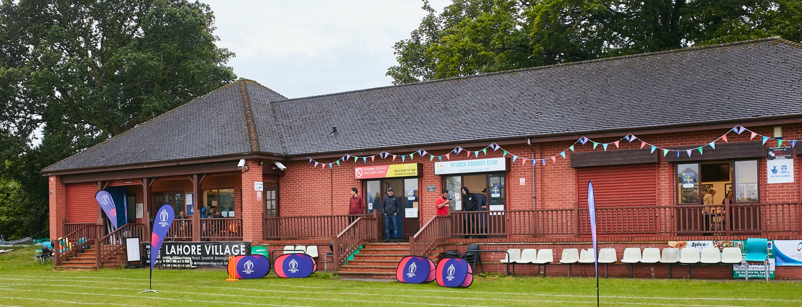

RISK ASSESSMENT TEMPLATE FOR CLUBS PREPARING TO OPEN THEIR CLUBHOUSE

Risk Assessment Template
As a facility provider, you should complete your own COVID-19 Risk Assessment and publish this to your users.

If you are not the facility provider, then you should consider which sections will apply to your clubs individual situation upon returning to play and complete a risk assessment based on your activity, including (but not limited to) people management and communication, hygiene and first aid. You may still wish to record that you have assessed facility risks through enquiries made with your facility provider.

We have provided an example risk assessment below, which is for illustrative purposes only, and includes some examples of things to consider. Consider how this will apply to each aspect of your operation and identify the controls you require to meet Government guidance regarding health, social distancing and hygiene etc. Remember that you must review your other Health and Safety, and Safeguarding, risk assessments for other hazards such as fire, first aid etc.

What are the hazards? |  | Transmission of COVID-19
Who might be harmed? |  | Facility users, staff, volunteers, visitors and the wider community
No | Controls required |  | Action Taken by the Club
People Management and Communication
 | Self-screening of individuals before they arrive at the venue to ensure individuals displaying COVID-19 symptoms or those who should be shielding do not travel or attend. |  | Communications to all players and opposition team captains prior to each senior game. Email to parents prior to start of junior coaching programme and discussed at registration event.
 | An assessment of user numbers, space capacities, venue circulation and layout planning to maintain social distancing. |  | Home changing room open for access to male toilet and emergency first aid area. Away changing room to remain locked.  Only Club Representatives are allowed to access the Clubhouse, and ladies to access the female toilet.
 | A plan for where parents and players will sit whilst watching cricket activities. |  | Players and parents informed by Coaches and Club Representatives on arrival of the need to maintain social distancing and ideally to remain in their cars.  Any outdoor seating to comply with social distancing and to be wiped down afterwards.
 | Signage and communication so that all participants and visitors are aware of the control measures in place and how to act appropriately to minimise the risk of transmission of COVID-19. |  | Signage for toilet access and hygiene information to posted in relevant areas.  Signage for refreshments to be displayed on relevant window and floor signs outside pavilion to be in place whilst queuing to purchase refreshments.
 | Staff and volunteer training to support the implementation of the plan, with suitable training records. |  | All Club representatives who clean the Changing rooms, Clubhouse, Coach juniors, and Club Captains have been briefed of measures to be put in place
Coaches and Club representatives to ensure all ECB measures for junior coaching e.g. use of one ball per player are complied with. All balls to be disinfected in ball buckets. Coaches to wipe down all equipment following all sessions.
Buildings
 | Assess ventilation in your building (natural and mechanical) and take appropriate measures to maximise ventilation and minimise risk of transmission. |  | Clubhouse windows and Home Changing room door kept open during matches.
 | Assess the maximum occupancy of your rooms at 2m social distancing (or 1m with risk mitigation where 2m is not possible) and establish a suitable circulation system/one-way system. Use signage and floor markings to communicate this. |  | Home Changing room open for access to male toilet and first aid point only. Away changing room to remain closed.  Clubhouse will remain closed except for access to the Ladies toilet and access for a club representative to serve refreshments via a table sited at the front door.
 | Assess the arrangement of seating areas to maintain social distancing and minimise the risk of transmission. |  | Club reps and Captains are responsible for placing seating outside the clubhouse to comply with social distancing.
 | Consider your wet weather plans and describe what actions you will take to maintain social distancing in wet weather. |  | Players will be requested to return to their cars in the event of bad weather.
Social and Hospitality Areas
 | Plan to solicit and maintain records of your member attendance, customers and visitors - to be maintained for 21 days and then destroyed. |  | Contact details for players and guests to be given to opposition Captain. Opposition Captains are asked to provide contact details for their players and guests before the start of matches.  A Register of attendance is taken at all senior and junior coaching sessions.
From | Identification of suitable areas for outdoor service that don’t overlap with cricket activity. |  | No football matches or coaching to be allowed at the same time as cricket matches/practice.
 | Steps taken to minimise time and the number of people at the bar. |  | Clubhouse will remain closed except for Club representatives to access the kitchen area to serve refreshments via table positioned at the front door after the match.  Access also for ladies to acess the female toilet.
 | Steps taken to minimise contact points at payment or around the hospitality space. |  | Members asked to pay via BACS on a monthly basis wherever possible.
 | Suitable PPE provision and training for staff and volunteers. |  | First Aiders and relevant Club representatives briefed.
 | Strategy for the safe serving, clearing and cleaning of glassware and tableware. |  | Bottled beers and cans to be served via the positioning of a table inside the entrance to the Clubhouse. Relevant distancing signage provided outside the window. No glasses or cups to be used. No food will be prepared or served in the Clubhouse.
 | Deep cleaning strategy to minimise COVID-19 transmission risk |  | Regular cleaning of Clubhouse and Changing rooms. Changing rooms cleaned washed and toilets disinfected on 10/4.  Relevant hand wash and wipes made available
 | Daily cleaning strategy to minimise COVID-19 transmission risk. |  | Cleaning to take place by Club representatives on all occasions when the Clubhouse and Changing Room is opened.
 | High-frequency touchpoint cleaning strategy to minimise COVID-19 transmission risk and how you will keep records. |  | High frequency touch points identified and a checklist created to ensure regular cleaning is carried out.
Hygiene and Cleaning
 | Materials, PPE and training that you have provided to your staff for effective cleaning. |  | Disinfectant, cleaning materials, hand gels and wipes purchased in sufficient volume to cater for all coaching and matches etc.
 | Provision of hand washing facilities with warm water, soap, disposable towels and bin. |  | Clubhouse and Changing room toilets have necessary washing and hygiene materials.
 | Provision of suitable hand sanitiser in locations around the facility to maintain frequent hand sanitisation. |  | Hand sanitiser provided to all players on a table outside the clubhouse, in both toilets and the emergency first aid area. Comply with ECB regulations for playing cricket.
 | Provision of suitable wipes and hand sanitiser on the field for hygiene breaks. |  | Suitable wipes and hand sanitiser purchased and made available during matches and coaching sessions.
 | What are the hazards? | Other venue hazards to be considered after temporary closure such as Legionnaire’s Disease, fire, electrical safety etc.
 | Who might be harmed? | Facility users, staff, volunteers and visitors
 | Controls required |  | Action Taken by the Club
Preparing Your Buildings
 | Consider the risk of Legionnaire’s disease and carry out necessary work to make your water supply safe for users. Refer to the specific guidance in the document above. |  | Arrange for annual Fire safety test to be organised by Fire Central Control asap.
 | Check that routine maintenance has not been missed and certification is up to date (e.g. Gas safety, Electrical Safety and Portable Appliance Testing, Fire Safety, Lifts and Heating – Ventilation and Air Conditioning).
 | Check that your ground is ready and safe to play. Look at what work is required and how this can be done safely at a social distance.
 | What are the hazards? | Vital first aid equipment is not available when needed. First aiders do not have adequate PPE to carry out first aid when required.
 | Who might be harmed? | First aiders, facility users, staff, volunteers and visitors
 | Controls required |  | Action Taken by the Club
First Aid
 | Check that your first aid kits are stocked and accessible during all activity. |  | First aid equipment checked on 10/4. First Aid bag made available on table for all Junior coaching sessions. Will be placed in emergency area in Changing Room for all home games.
 | What steps have you taken to improve your first aiders’ understanding of first aid provision under COVID-19? |  | First Aiders and Club Representatives briefed on arrangements.
 | If you have an AED then check that it is in working order, service is up to date and that it is available during all activity. |  | N/A
 | What are the hazards? | Pitches or outfield are unsafe to play on
 | Who might be harmed? | Players, officials, ground staff
 | Controls required |  | Action Taken by the Club
Preparing your Grounds
 | Safety checks on machinery, sightscreens and covers. |  | See below schedule of activity
 | Check and repair of any damage to pitches and outfields. |  | Repair of section of non turf wicket to be completed prior to start of any matches.
 | Surfaces checked and watering regime adjusted based on lack of rainfall. |  | Weekly programme of ground maintenance started in early May.
Carried out annual service for Hayter mower – March 2021
Carried out annual services for wicket mowers – March 2021
Repaired mobile and static nets – April 2021
Remove all rubbish from rear of the Clubhouse and tractor shed – April 2021
Repaired mobile covers and sightscreens – April 2021
Hired large roller to roll wicket and outfield – March 2021
Inspected outfield section by football pitch and filled divots etc – March 2021

e | What are the hazards? | Tractor Shed
 | Who might be harmed? | Groundsman and Club members helping to work on wickets and outfield.
 | Controls required |  | Action Taken by the Club
 | Ensure Tractor Shed is safe for club representatives to access machinery etc |  | Checked contents of First Aid bag to ensure still in date – April 202.
 |  |  | Removed all rubbish from within building including damaged static net frame – April 2021
Completed visual inspection of tractor shed roof – March 2021.
Refitted damaged umpires door – April 2021.

 | What are the hazards?
 | Who might be harmed? | Use this space to identify who might be harmed
 | Controls required |  | Action Taken by the Club
 | Identify your own control measures required.

 | What are the hazards? | Use this space to identify hazards at your venue
 | Who might be harmed? | Use this space to identify who might be harmed
 | Controls required |  | Action Taken by the Club
 | Identify your own control measures required.

