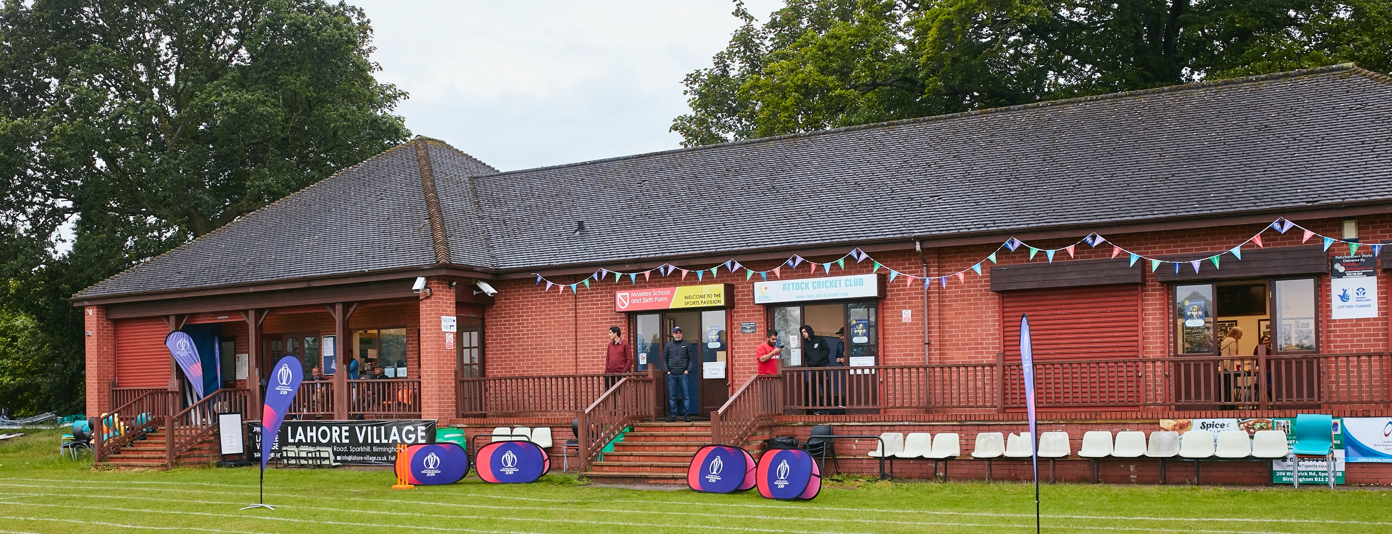

RISK ASSESSMENT TEMPLATE FOR BISHOPS CASTLE CC - RETURN TO PLAYING 2021

What are the hazards? |  | Transmission of COVID-19
Who might be harmed? |  | Facility users, staff, volunteers, visitors and the wider community
No | Controls required |  | Action Taken by the Club
People Management and Communication
 | Self-screening of individuals before they arrive at the venue to ensure individuals displaying COVID-19 symptoms or those who should be shielding do not travel or attend. |  | Via the website and signage, ALL visitors and participants should be aware of the need to self-screen with regards to the established symptoms of COVID-19.
 | An assessment of user numbers, space capacities, venue circulation and layout planning to maintain social distancing. |  | There will be a maximum of 30 “users” on our site (players, umpires, coaches, First Aid), unless emergency services are called. There will be no spectators or casual visitors allowed. One-Way entry and exit procedures will be in place (signposted), with reminder signage as per social distancing.
 | A plan for where parents and players will sit whilst watching cricket activities. |  | Players will sit or stand at socially-distanced intervals, and will not use the changing rooms for changing or showering, or for spectating purposes. In the event of wet weather, players/parents will need to return to their vehicles; the issue of wet weather will be uppermost in our decisions as to whether to postpone a game if there is a significant chance of wet weather during the paying hours.
 | Signage and communication so that all participants and visitors are aware of the control measures in place and how to act appropriately to minimise the risk of transmission of COVID-19. |  | There will be appropriate signage and entrances and exits, doors and windows, as well as the Club’s website.
 | Staff and volunteer training to support the implementation of the plan, with suitable training records. |  | The Secretary has briefed members appropriately, and they will continue to be informed and reminded of the requirements; this Risk Assessment will be available at all times.
Buildings
 | Assess ventilation in your building (natural and mechanical) and take appropriate measures to maximise ventilation and minimise risk of transmission. |  | The Club’s building will open only for toilet usage and for the availability of First Aid; ventilation is adequate in terms of windows, and doors will be kept open. There is no air conditioning at the Club.
 | Assess the maximum occupancy of your rooms at 2m social distancing (or 1m with risk mitigation where 2m is not possible) and establish a suitable circulation system/one-way system. Use signage and floor markings to communicate this. |  | Entry and exit is one-way, there is signage for toilet usage and procedures afterwards, with occupancy of one person at a time in the entire building. A queuing system will be strictly enforced.
 | Assess the arrangement of seating areas to maintain social distancing and minimise the risk of transmission. |  | There is minimal seating at the Club, and this has been assessed and appropriately limited to ensure social distancing.
 | Consider your wet weather plans and describe what actions you will take to maintain social distancing in wet weather. |  | The game is likely to be called off if there is significant risk of wet weather; if such weather is not foreseeable, and there is inclement weather, users will be required to return to their vehicles. Should this response be difficult to maintain, then the game will be cancelled.
Social and Hospitality Areas – THERE ARE NO SOCUAL OR HOSPITALITY AREAS IN OPERATION
 | Plan to solicit and maintain records of your member attendance, customers and visitors - to be maintained for 21 days and then destroyed. |  | There will be a requirement for the Captains to have completed registers, to include names and telephone numbers.
 | Identification of suitable areas for outdoor service that don’t overlap with cricket activity. |  | Not Applicable (no service).
 | Steps taken to minimise time and the number of people at the bar. |  | Not Applicable (no bar).
 | Steps taken to minimise contact points at payment or around the hospitality space. |  | Not Applicable.
 | Suitable PPE provision and training for staff and volunteers. |  | PPE and First aid provision is present. Briefings for the use of sanitizer, masks (if worn), management of the ball (eg no saliva applied).
 | Strategy for the safe serving, clearing and cleaning of glassware and tableware. |  | Not Applicable (players will bring their own refreshments).
 | Deep cleaning strategy to minimise COVID-19 transmission risk |  | Before and after each game, there will be a thorough cleaning: equipment, door handles, window handles, toilets, sinks, gates, sightscreen handles, boundaries markers and discs.
 | Daily cleaning strategy to minimise COVID-19 transmission risk. |  | Not Applicable – see above.
 | High-frequency touchpoint cleaning strategy to minimise COVID-19 transmission risk and how you will keep records. |  | A register of cleaning will be kept on the way changing room noticeboard, to log the cleaning of such high frequency touchpoints (as above).
Hygiene and Cleaning
 | Materials, PPE and training that you have provided to your staff for effective cleaning. |  | A briefing session was held on 18th July 2020, and reminders for the 2021 season given.
 | Provision of hand washing facilities with warm water, soap, disposable towels and bin. |  | Full provision.
 | Provision of suitable hand sanitiser in locations around the facility to maintain frequent hand sanitisation. |  | Full provision.
 | Provision of suitable wipes and hand sanitiser on the field for hygiene breaks. |  | Full provision.
 | What are the hazards? | Other venue hazards to be considered after temporary closure such as Legionnaire’s Disease, fire, electrical safety etc.
 | Who might be harmed? | Facility users, staff, volunteers and visitors
 | Controls required |  | Action Taken by the Club
Preparing Your Buildings
 | Consider the risk of Legionnaire’s disease and carry out necessary work to make your water supply safe for users. Refer to the specific guidance in the document above. |  | There has been weekly running of facilities during the break, as per usual.
 | Check that routine maintenance has not been missed and certification is up to date (e.g. Gas safety, Electrical Safety and Portable Appliance Testing, Fire Safety, Lifts and Heating – Ventilation and Air Conditioning). |  | Water facilities have been checked by a registered engineer; there are no gas or electrical appliances, no lifts and no heating.
 | Check that your ground is ready and safe to play. Look at what work is required and how this can be done safely at a social distance. |  | Checks have been carried out and we deem the ground to be safe to play.
 | What are the hazards? | Vital first aid equipment is not available when needed. First aiders do not have adequate PPE to carry out first aid when required.
 | Who might be harmed? | First aiders, facility users, staff, volunteers and visitors
 | Controls required |  | Action Taken by the Club
First Aid
 | Check that your first aid kits are stocked and accessible during all activity. |  | First aid kits are fully stocked and accessible (located in the former “tea room”), and they will be accessed by the relevant First Aider.
 | What steps have you taken to improve your first aiders’ understanding of first aid provision under COVID-19? |  | The briefing of First Aiders, regarding their own safety, has been provided (eg masks, shields and other PPE).
 | If you have an AED then check that it is in working order, service is up to date and that it is available during all activity. |  | Not applicable.
 | What are the hazards? | Potentially, pitches or outfield are unsafe to play on
 | Who might be harmed? | Potentially, players, officials, ground staff
 | Controls required |  | Action Taken by the Club
Preparing your Grounds
 | Safety checks on machinery, sightscreens and covers. |  | Checks have been carried out -new sight screen purchased.
 | Check and repair of any damage to pitches and outfields. |  | Check have been carried out on a weekly basis, and will also be carried out prior to each game.
 | Surfaces checked and watering regime adjusted based on lack of rainfall. |  | A hosepipe is available, when required.
 | What are the hazards? | Occasional overhanging branches to trees on one area of the boundary.
 | Who might be harmed? | Players (no spectators).
 | Controls required |  | Action Taken by the Club
 | Identify your own control measures required. |  | Tree surgeon employed to manage and remove any risk.

 | What are the hazards? | Occasional vermin due to the rural nature of the ground (ie rats, moles, insects).
 | Who might be harmed? | Players/Officials, Coaches.
 | Controls required |  | Action Taken by the Club
 | Identify your own control measures required. |  | Pest-Control specialist engaged to remove the risk.

 | What are the hazards? | Machinery that may develop faults.
 | Who might be harmed? | The operative
 | Controls required |  | Action Taken by the Club
 | Identify your own control measures required. |  | Safety of machinery assessed by operatives, and where issues arise a suitably qualified engineer is engaged by the Club to remedy the issue.

