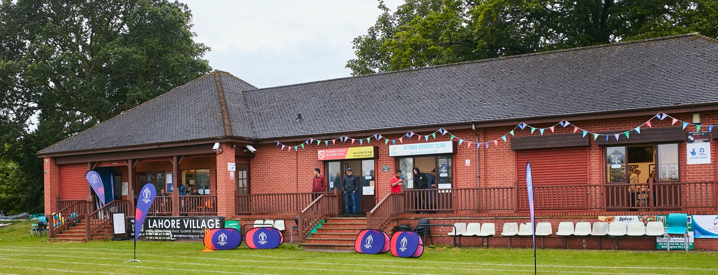

RISK ASSESSMENT TEMPLATE FOR CLUBS PREPARING TO OPEN THEIR CLUBHOUSE

Risk Assessment Template
As a facility provider, you should complete your own COVID-19 Risk Assessment and publish this to your users.

If you are not the facility provider, then you should consider which sections will apply to your clubs individual situation upon returning to play and complete a risk assessment based on your activity, including (but not limited to) people management and communication, hygiene and first aid. You may still wish to record that you have assessed facility risks through enquiries made with your facility provider.

We have provided an example risk assessment below, which is for illustrative purposes only, and includes some examples of things to consider. Consider how this will apply to each aspect of your operation and identify the controls you require to meet Government guidance regarding health, social distancing and hygiene etc. Remember that you must review your other Health and Safety, and Safeguarding, risk assessments for other hazards such as fire, first aid etc.

What are the hazards? |  | Transmission of COVID-19
Who might be harmed? |  | Facility users, staff, volunteers, visitors and the wider community
No | Controls required |  | Action Taken by the Club
People Management and Communication
 | Self-screening of individuals before they arrive at the venue to ensure individuals displaying COVID-19 symptoms or those who should be shielding do not travel or attend. |  | Individuals will be advised not to travel or attend sessions if they are displaying Covid-19 symptoms. This will be communicated through our social media platforms and on arrival.
 | An assessment of user numbers, space capacities, venue circulation and layout planning to maintain social distancing. |  | Weekly assessments will be undertaken by members of the Club’s cricket committee based on the activities due to take place at the club during that week. Use of indoor facilities will be restricted, but where necessary signage and layout plans will maintain social distancing restrictions.
 | A plan for where parents and players will sit whilst watching cricket activities. |  | Seating in position and parents will be reminded of their social distancing responsibilities.
 | Signage and communication so that all participants and visitors are aware of the control measures in place and how to act appropriately to minimise the risk of transmission of COVID-19. |  | All members and visitors will be made aware of the control measures in place on arrival by authorized members of the club. Signage will be permanently in place to reinforce control measures.
 | Staff and volunteer training to support the implementation of the plan, with suitable training records. |  | Committee members to attend appropriate training events as indicated by the ECB, Shropshire Cricket Board, and the Shropshire County Cricket League
Buildings
 | Assess ventilation in your building (natural and mechanical) and take appropriate measures to maximise ventilation and minimise risk of transmission. |  | Main and side doors to the Pavilion will be open throughout the duration of the game / training session to maximize ventilation and minimize risk of transmission
 | Assess the maximum occupancy of your rooms at 2m social distancing (or 1m with risk mitigation where 2m is not possible) and establish a suitable circulation system/one-way system. Use signage and floor markings to communicate this. |  | Entrance to the Pavilion will be for authorized members of the club and a maximum of one visitor only. A one-way system and signage will be in place to allow one visitor at a time to access the bar facilities within the Pavilion
 | Assess the arrangement of seating areas to maintain social distancing and minimise the risk of transmission. |  | All outdoor seating areas will maintain 2 metre distancing. Indoor accessibility will be limited to one person at a time.
 | Consider your wet weather plans and describe what actions you will take to maintain social distancing in wet weather. |  | Gazebos will be in place to ensure that visiting teams will still have safe places to be located alongside their playing equipment. Indoor usage will still be restricted even in the advent of wet weather. Players will be encouraged to return to their cars if weather deteriorates.
Social and Hospitality Areas
 | Plan to solicit and maintain records of your member attendance, customers and visitors - to be maintained for 21 days and then destroyed. |  | A Track and Trace system is in place with safe storage for individual personal details located on site.
 | Identification of suitable areas for outdoor service that don’t overlap with cricket activity. |  | Outdoor service areas will be restricted to tables located near the pavilion. Players and cricket activity will be away from this area.
 | Steps taken to minimise time and the number of people at the bar. |  | Only one person will be allowed into the bar area at a time to maintain social distancing measures and reduce the level of contact between individuals. This will be monitored by the bar staff and committee members. Access / Exit to the bar area will be done through a one-way system that will be clearly signposted.
 | Steps taken to minimise contact points at payment or around the hospitality space. |  | Contactless payment options are now available at the bar area to minimize time individuals need at the bar.
 | Suitable PPE provision and training for staff and volunteers. |  | PPE in place including individual plastic shielding for bar staff and a bespoke plastic hatch for safe serving.
 | Strategy for the safe serving, clearing and cleaning of glassware and tableware. |  | A plastic hatch at the bar will now provide a safe serving environment. Glasses will be collected on a regular basis and will not be reused until thoroughly cleaned and quarantined for 24 hours. Cleaning of all communal areas will take place after all activity has been completed.
 | Deep cleaning strategy to minimise COVID-19 transmission risk |  | Deep Cleaning to take place on a weekly basis by authorized members of the Cricket Club
 | Daily cleaning strategy to minimise COVID-19 transmission risk. |  | Daily Cleaning to take place after all activities have been completed by authorized members of the Cricket Club
 | High-frequency touchpoint cleaning strategy to minimise COVID-19 transmission risk and how you will keep records. |  | Regular cleaning of high touch point areas will take place during the activity by club staff. All cleaning activity will be recorded accordingly.
Hygiene and Cleaning
 | Materials, PPE and training that you have provided to your staff for effective cleaning. |  | All bar staff will be provided with face masks and gloves. These will be mandatory for all staff to wear during any cleaning procedures but will also be available should staff choose to wear them during activity.
 | Provision of hand washing facilities with warm water, soap, disposable towels and bin. |  | Yes, all available at various locations within the pavilion, however, use of these will be restricted to authorized club members and only in the case of emergencies.
 | Provision of suitable hand sanitiser in locations around the facility to maintain frequent hand sanitisation. |  | Hand Sanitizers will be located around the ground for public use. All players will be expected to spray and sanitize their equipment after every session. Bar staff must wear PPE whilst sanitizing equipment – record on logs.
 | Provision of suitable wipes and hand sanitiser on the field for hygiene breaks. |  | Yes, wipes and sanitizers will be made available during all hygiene breaks
 | What are the hazards? | Other venue hazards to be considered after temporary closure such as Legionnaire’s Disease, fire, electrical safety etc.
 | Who might be harmed? | Facility users, staff, volunteers and visitors
 | Controls required |  | Action Taken by the Club
Preparing Your Buildings
 | Consider the risk of Legionnaire’s disease and carry out necessary work to make your water supply safe for users. Refer to the specific guidance in the document above. |  | Water checks have been undertaken by the owners of the ground and we have evidence of Legionnaire’s Disease.
 | Check that routine maintenance has not been missed and certification is up to date (e.g. Gas safety, Electrical Safety and Portable Appliance Testing, Fire Safety, Lifts and Heating – Ventilation and Air Conditioning). |  | Up to date Electrical Safety check in place and certificates on display in the Pavilion. No Gas on site.
 | Check that your ground is ready and safe to play. Look at what work is required and how this can be done safely at a social distance. |  | Groundwork has been completed and conducted in a safe manner.
 | What are the hazards? | Vital first aid equipment is not available when needed. First aiders do not have adequate PPE to carry out first aid when required.
 | Who might be harmed? | First aiders, facility users, staff, volunteers and visitors
 | Controls required |  | Action Taken by the Club
First Aid
 | Check that your first aid kits are stocked and accessible during all activity. |  | All Frist Aid kits have been restocked during the close season and are accessible to club staff and coaches.
 | What steps have you taken to improve your first aiders’ understanding of first aid provision under COVID-19? |  | All staff to have necessary PPE available. Should a first aid incident occur where contact is necessary, staff must wear face mask and gloves before moving within 2m of the injured participant. Where possible keep any first aid intervention to less then 15 minutes. Adhere to social distancing where possible in all instances
 | If you have an AED then check that it is in working order, service is up to date and that it is available during all activity. |  | AED has been checked and serviced during the close season is available to use.
 | What are the hazards? | Pitches or outfield are unsafe to play on
 | Who might be harmed? | Players, officials, ground staff
 | Controls required |  | Action Taken by the Club
Preparing your Grounds
 | Safety checks on machinery, sightscreens and covers. |  | Weekly checks will take place of the safety of grounds equipment. Use of machinery will be restricted to authorized club members. Where sightscreens and covers have been used during the game, immediate cleaning of communal surfaces will be encouraged.
 | Check and repair of any damage to pitches and outfields. |  | Pitch and outfield checks will be restricted to authorized ground staff who will be wearing the appropriate PPE.
 | Surfaces checked and watering regime adjusted based on lack of rainfall.
 | What are the hazards? | Use this space to identify hazards at your venue
 | Who might be harmed? | Use this space to identify who might be harmed
 | Controls required |  | Action Taken by the Club
 | Identify your own control measures required.

 | What are the hazards? | Use this space to identify hazards at your venue
 | Who might be harmed? | Use this space to identify who might be harmed
 | Controls required |  | Action Taken by the Club
 | Identify your own control measures required.

 | What are the hazards? | Use this space to identify hazards at your venue
 | Who might be harmed? | Use this space to identify who might be harmed
 | Controls required |  | Action Taken by the Club
 | Identify your own control measures required.

