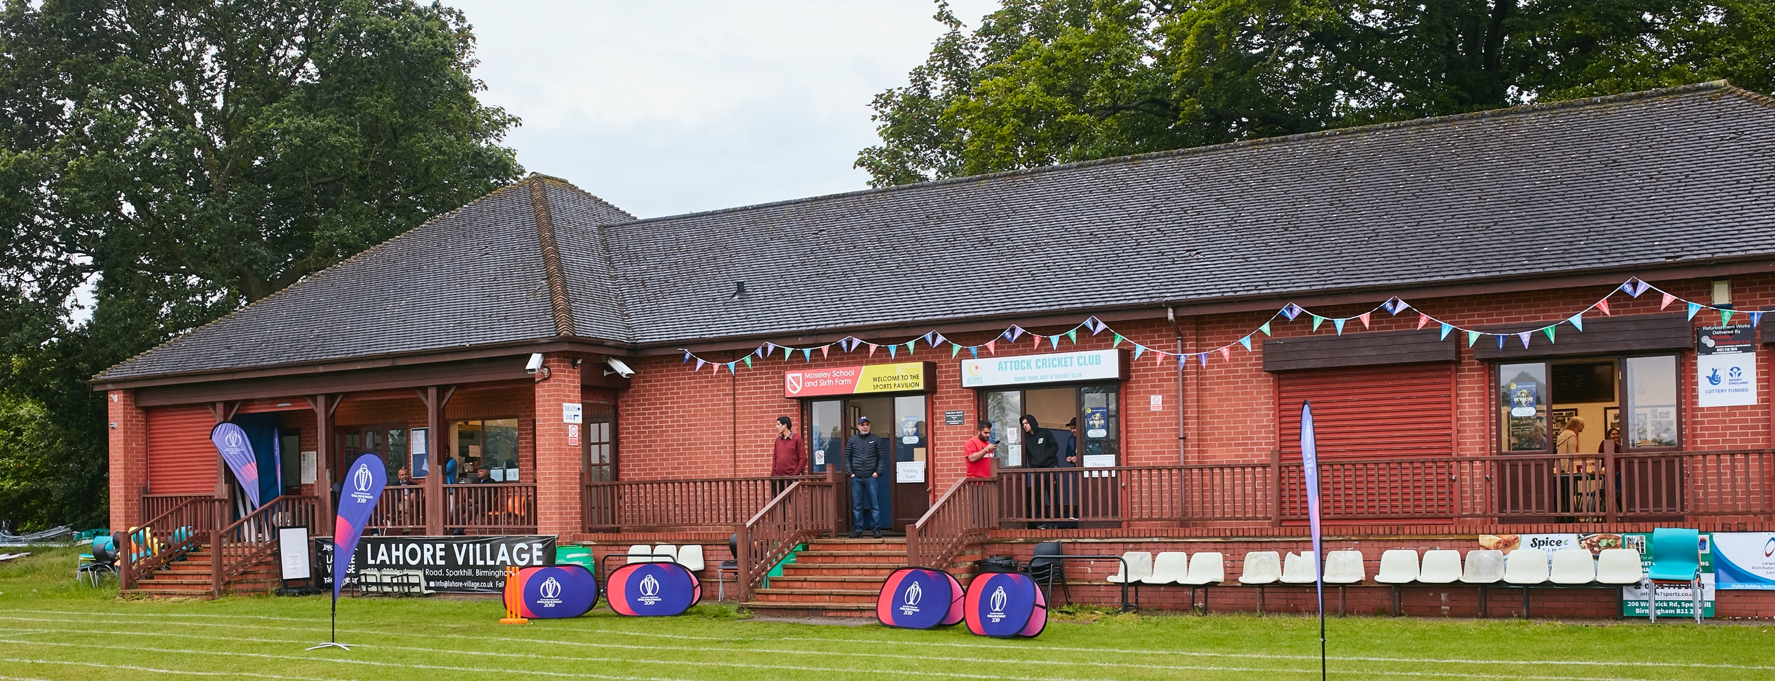

RISK ASSESSMENT TEMPLATE FOR CLUBS PREPARING TO OPEN THEIR CLUBHOUSE

Risk Assessment Template
As a facility provider, you should complete your own COVID-19 Risk Assessment and publish this to your users.

If you are not the facility provider, then you should consider which sections will apply to your clubs individual situation upon returning to play and complete a risk assessment based on your activity, including (but not limited to) people management and communication, hygiene and first aid. You may still wish to record that you have assessed facility risks through enquiries made with your facility provider.

We have provided an example risk assessment below, which is for illustrative purposes only, and includes some examples of things to consider. Consider how this will apply to each aspect of your operation and identify the controls you require to meet Government guidance regarding health, social distancing and hygiene etc. Remember that you must review your other Health and Safety, and Safeguarding, risk assessments for other hazards such as fire, first aid etc.

What are the hazards? |  | Transmission of COVID-19
Who might be harmed? |  | Facility users, staff, volunteers, visitors and the wider community
No | Controls required |  | Action Taken by the Club
People Management and Communication
 | Self-screening of individuals before they arrive at the venue to ensure individuals displaying COVID-19 symptoms or those who should be shielding do not travel or attend. |  | Open communications (face-book, email, verbal) to all playing & non-playing Members including Junior Member parents / guardians;  Briefings for Committee Members, Club Captain & Team Captains.
 | An assessment of user numbers, space capacities, venue circulation and layout planning to maintain social distancing. |  | Separate Risk Assessment completed for use of clubhouse (bar & toilets) with social distancing signs and pre/during/post event cleaning regime
 | A plan for where parents and players will sit whilst watching cricket activities. |  | Benches to be set out prior to games to encourage social distancing.
 | Signage and communication so that all participants and visitors are aware of the control measures in place and how to act appropriately to minimise the risk of transmission of COVID-19. |  | Signage in-place;  Review during pre-season friendly fixtures on Saturday 10/04/2021 and amend as required prior to first competitive fixture(s)
 | Staff and volunteer training to support the implementation of the plan, with suitable training records. |  | Briefing note issued to Committee Members, Club Captain, Team Captain and all volunteers  Review briefing via on-line Committee Meeting on 13/04/2021
Buildings
 | Assess ventilation in your building (natural and mechanical) and take appropriate measures to maximise ventilation and minimise risk of transmission. |  | One-way system for bar and toilets in operation with social distancing markers / signs and hand-cleansing stations;  Open additional windows as weather conditions permit / require;  Players may use respective home / away changing rooms for toilet use only.
 | Assess the maximum occupancy of your rooms at 2m social distancing (or 1m with risk mitigation where 2m is not possible) and establish a suitable circulation system/one-way system. Use signage and floor markings to communicate this. |  | Separate Risk Assessment completed for bar and toilet facilities
 | Assess the arrangement of seating areas to maintain social distancing and minimise the risk of transmission. |  | Separate Risk Assessment completed for bar and toilet facilities;  No provision for internal seating at this stage;  Re-assess situation as the health risk diminishes.
 | Consider your wet weather plans and describe what actions you will take to maintain social distancing in wet weather. |  | Minimal provision available on the ground, in changing rooms or within the clubhouse; Principle means of shelter provided by player / spectator car(s); scope for a small number of individuals to shelter in or adjacent to the changing rooms subject to safe social distancing.
Social and Hospitality Areas
 | Plan to solicit and maintain records of your member attendance, customers and visitors - to be maintained for 21 days and then destroyed. |  | Record of attendance for all attendees (or at least the lead Member) to be held at each game / event.
 | Identification of suitable areas for outdoor service that don’t overlap with cricket activity. |  | N/A – one way system developed for use of the bar and toilet facilities with appropriate signage and hand sanitizing stations.
 | Steps taken to minimise time and the number of people at the bar. |  | See separate Risk Assessment for bar and toilet facilities.
 | Steps taken to minimise contact points at payment or around the hospitality space. |  | See separate Risk Assessment for bar and toilet facilities – cashless payments only.
 | Suitable PPE provision and training for staff and volunteers. |  | All staff briefed and PPE provided (local provision plus Nat West box)
 | Strategy for the safe serving, clearing and cleaning of glassware and tableware. |  | See separate Risk Assessment for bar and toilet facilities.
 | Deep cleaning strategy to minimise COVID-19 transmission risk |  | All facilities to be cleaned pre/post game or event. A thorough deep-clean to be provided between all games and events. Cleaner briefed and additional hours agreed as required.
 | Daily cleaning strategy to minimise COVID-19 transmission risk. |  | As above (facility not in current daily use).
 | High-frequency touchpoint cleaning strategy to minimise COVID-19 transmission risk and how you will keep records. |  | Staff briefed to carry out regular sanitizing of higher risk touchpoints.
Hygiene and Cleaning
 | Materials, PPE and training that you have provided to your staff for effective cleaning. |  | Full Covid 19 briefing provided for the cleaner; Additional cleansing materials purchased; Comprehensive cleansing / sanitizing regime now in place; PPE equipment purchased and available to all staff / volunteers.
 | Provision of hand washing facilities with warm water, soap, disposable towels and bin. |  | Normal procedures and facilities in place with additional signage; Hand-towels to be provided along with new disposal bins..
 | Provision of suitable hand sanitiser in locations around the facility to maintain frequent hand sanitisation. |  | Hand sanitizer(s) available at entry and exit points to the clubhouse including toilet facilities.
 | Provision of suitable wipes and hand sanitiser on the field for hygiene breaks. |  | Additional hand sanitizers to be provided for on-field
 | What are the hazards? | Other venue hazards to be considered after temporary closure such as Legionnaire’s Disease, fire, electrical safety etc.
 | Who might be harmed? | Facility users, staff, volunteers and visitors
 | Controls required |  | Action Taken by the Club
Preparing Your Buildings
 | Consider the risk of Legionnaire’s disease and carry out necessary work to make your water supply safe for users. Refer to the specific guidance in the document above. |  | Pre-season cleansing and testing of shower and other water supply facilities carried out.
 | Check that routine maintenance has not been missed and certification is up to date (e.g. Gas safety, Electrical Safety and Portable Appliance Testing, Fire Safety, Lifts and Heating – Ventilation and Air Conditioning). |  | Regular servicing of gas and electrical appliances up-to-date; PAT tests carried out and new equipment provided
 | Check that your ground is ready and safe to play. Look at what work is required and how this can be done safely at a social distance. |  | Grounds maintenance procedures in place and operating well; Groundsman / assistants fully briefed in safe operational practice and social distancing
 | What are the hazards? | Vital first aid equipment is not available when needed. First aiders do not have adequate PPE to carry out first aid when required.
 | Who might be harmed? | First aiders, facility users, staff, volunteers and visitors
 | Controls required |  | Action Taken by the Club
First Aid
 | Check that your first aid kits are stocked and accessible during all activity. |  | Annual pre-season checks and re-stocking of first aid equipment carried out;  Regular checks of first aid bags carried out with re-stocking as required;  Additional first aid supplies held in reserve.
 | What steps have you taken to improve your first aiders’ understanding of first aid provision under COVID-19? |  | ECB guidance shared with all first-aiders with instructions to follow safe practice.
 | If you have an AED then check that it is in working order, service is up to date and that it is available during all activity. |  | Not Applicable
 | What are the hazards? | Pitches or outfield are unsafe to play on
 | Who might be harmed? | Players, officials, ground staff
 | Controls required |  | Action Taken by the Club
Preparing your Grounds
 | Safety checks on machinery, sightscreens and covers. |  | Pre-season safety checks carried out on Saturday 10th April 2021
 | Check and repair of any damage to pitches and outfields. |  | Pre-season safety checks carried out as above; Regular inspection of ground and external facilities carried out by the Groundsman / assistants
 | Surfaces checked and watering regime adjusted based on lack of rainfall. |  | Regular inspection of ground and external facilities carried out by the Groundsman / assistants; Playing surfaces regularly checked and watered as required.
 | What are the hazards? | Use this space to identify hazards at your venue
 | Who might be harmed? | Use this space to identify who might be harmed
 | Controls required |  | Action Taken by the Club
 | Identify your own control measures required.

