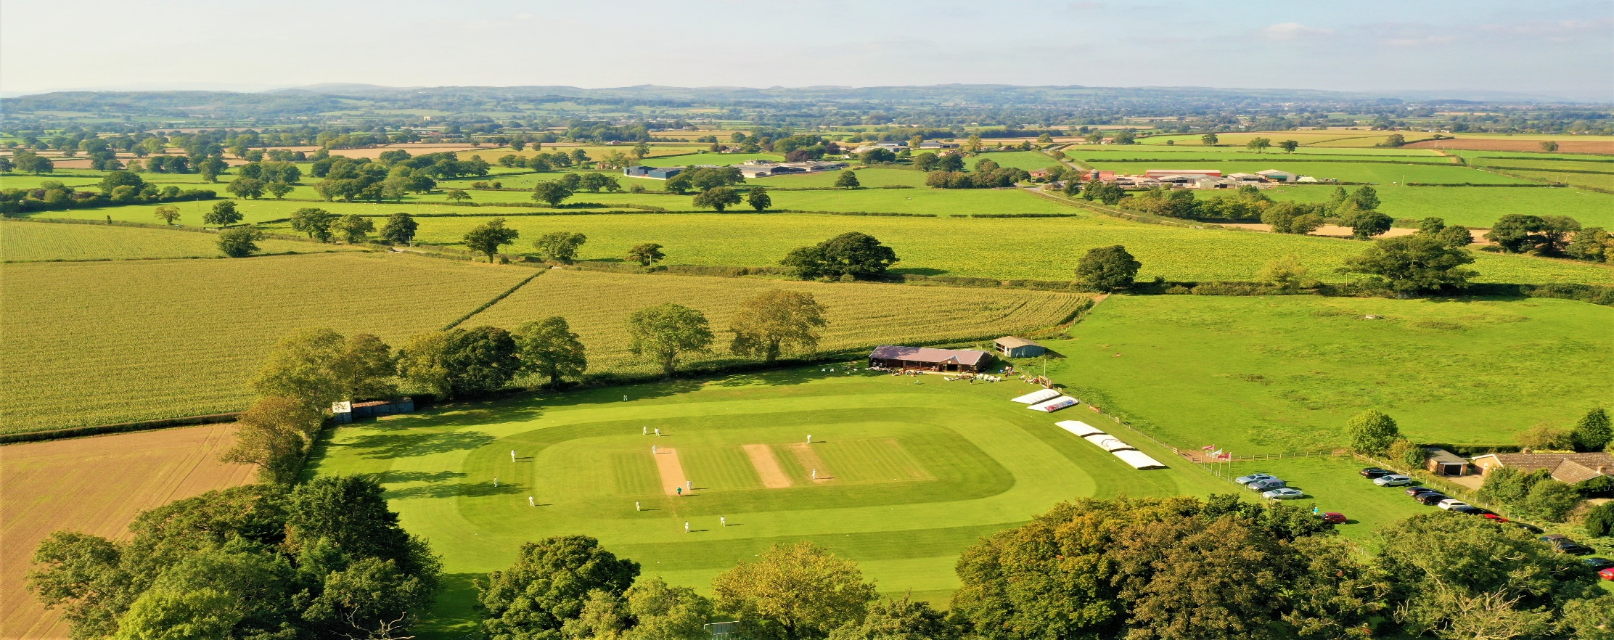

RISK ASSESSMENT FOR KNOCKIN AND KINNERLEY CRICKET CLUB PREPARING TO OPEN THEIR CLUBHOUSE

Risk Assessment Template
As a facility provider, you should complete your own COVID-19 Risk Assessment and publish this to your users.

If you are not the facility provider, then you should consider which sections will apply to your clubs individual situation upon returning to play and complete a risk assessment based on your activity, including (but not limited to) people management and communication, hygiene and first aid. You may still wish to record that you have assessed facility risks through enquiries made with your facility provider.

We have provided an example risk assessment below, which is for illustrative purposes only, and includes some examples of things to consider. Consider how this will apply to each aspect of your operation and identify the controls you require to meet Government guidance regarding health, social distancing and hygiene etc. Remember that you must review your other Health and Safety, and Safeguarding, risk assessments for other hazards such as fire, first aid etc.

What are the hazards? |  | Transmission of COVID-19
Who might be harmed? |  | Facility users, staff, volunteers, visitors and the wider community
No | Controls required |  | Action Taken by the Club
People Management and Communication
 | Self-screening of individuals before they arrive at the venue to ensure individuals displaying COVID-19 symptoms or those who should be shielding do not travel or attend. |  | Email sent to all KKCC Members W/C 12th April highlighting the latest roadmap self-screening safeguards and travel restrictions.
 | An assessment of user numbers, space capacities, venue circulation and layout planning to maintain social distancing. |  | The Nursery Ground has been set up with two specific areas for the home and away team at either ends of the clubhouse. Seating within these sections are socially distant. KKCC will adhere to the strict rule of no spectators and limit the maximum amount of people at the ground including players to thirty. Clubhouse will only be used for toilet facilities and limited purchases from the club shop within social distance rules.
 | A plan for where parents and players will sit whilst watching cricket activities. |  | As above, seating will be placed on the grass in front of the pavilion for the two teams. As per new guidance spectators are not permitted and no provision will be made for them unless they are carers for one of the players. Seating on the veranda is also optional, but 2m social distancing must be observed.
 | Signage and communication so that all participants and visitors are aware of the control measures in place and how to act appropriately to minimise the risk of transmission of COVID-19. |  | Signage indicating control measures in effect will be placed outside the pavilion, in the main room, kitchen and toilet. A simple directional flow system will be in place for anyone using the pavilion for toilet or club shop facilities.
 | Staff and volunteer training to support the implementation of the plan, with suitable training records. |  | Training and awareness for volunteers will be conducted and refreshed at the start of each social/sporting gathering event. Secretary of the Club will train all Captains on new protocols during the first home game of the season.

Buildings
 | Assess ventilation in your building (natural and mechanical) and take appropriate measures to maximise ventilation and minimise risk of transmission. | Main pavilion doors, side entrance and rear kitchen windows will be open during events.
 | Assess the maximum occupancy of your rooms at 2m social distancing (or 1m with risk mitigation where 2m is not possible) and establish a suitable circulation system/one-way system. Use signage and floor markings to communicate this. | Only the main pavilion room, its toilet and kitchen will be available for use. Changing rooms will be closed. Playing members will be required to arrive in cricket gear, ready to play.  The kitchen will allow one server at any time, or two when risk is mitigated (wearing of mask, gloves). A one-way system will feed attendees into the room through the main doors to the serving hatch and then out through the side door. Place for one waiting for the toilet set aside. Hazard tape will delineate social distancing. Maximum 6 people in the main room.
 | Assess the arrangement of seating areas to maintain social distancing and minimise the risk of transmission. | All attendees will be seated outside the pavilion on the grass or veranda. No seating will be available indoors.
 | Consider your wet weather plans and describe what actions you will take to maintain social distancing in wet weather. | In wet weather attendees and players will be required to wait in their cars. Only volunteers will be able to use the veranda and main room.
PLAYING

Social and Hospitality Areas
 | Plan to solicit and maintain records of your member attendance, customers and visitors - to be maintained for 21 days and then destroyed. | A calendar of club events will be created and will need to be maintained. Participating member’s attendance will be registered on a spreadsheet for each event. Parents and visiting non-members will be asked to complete an attendance register which will be retained for 21 days then destroyed. A club representative will be allocated for each event and will be required to ensure this is undertaken. The NHS QR Code is clearly identifiable at the club for all visitors to use.
 | Identification of suitable areas for outdoor service that don’t overlap with cricket activity. | Not applicable. No outdoor service will be provided.
 | Steps taken to minimise time and the number of people at the bar. | Only one person will be allowed at the serving hatch at any one time.
 | Steps taken to minimise contact points at payment or around the hospitality space. | Payment will be by cash / contactless to servers and exact change will be preferred when paying with cash. Anti-bacterial hand gel will be available for cleaning of hands following handling of cash.
 | Suitable PPE provision and training for staff and volunteers. | Anti-bacterial hand gel, wipes, masks and gloves will be provided for all volunteers.
 | Strategy for the safe serving, clearing and cleaning of glassware and tableware. | The club’s crockery will be used. Attendees will be asked to place used crockery at a specific place (outdoor table). It will be collected only by a volunteer server and taken indoors for high temperature machine dishwashing.
 | Deep cleaning strategy to minimise COVID-19 transmission risk | The Clubhouse will be deep cleaned by our employed cleaner before the start of the season and on every Friday and Monday after and before the weekend games.
 | Daily cleaning strategy to minimise COVID-19 transmission risk. | The main room, kitchen and toilet will be cleaned at the start and finish of each event in addition to the above cleaning regime.
 | High-frequency touchpoint cleaning strategy to minimise COVID-19 transmission risk and how you will keep records. | Kitchen and toilet door handles and toilet bin emptying will be conducted every 30 minutes during each event.

Hygiene and Cleaning
 | Materials, PPE and training that you have provided to your staff for effective cleaning. | Anti-bacterial hand gel, wipes, masks and gloves will be provided for all volunteers.
 | Provision of hand washing facilities with warm water, soap, disposable towels and bin. | Warm water, soap, disposable towels and bin will be provided.
 | Provision of suitable hand sanitiser in locations around the facility to maintain frequent hand sanitisation. | Anti-bacterial hand gel will be provided at relevant locations around and inside the pavilion.
 | Provision of suitable wipes and hand sanitiser on the field for hygiene breaks. | Competing players will be encouraged to bring their own small bottle of hand gel. They will be asked to use these after every occasion they handle the ball. Bowlers will be required to do so at the end of every over they bowl. Captains will be responsible for cleaning the ball as required by ECB playing guidelines.

 | What are the hazards? | Other venue hazards to be considered after temporary closure such as Legionnaire’s Disease, fire, electrical safety etc.
 | Who might be harmed? | Facility users, staff, volunteers and visitors
 | Controls required |  | Action Taken by the Club
Preparing Your Buildings
 | Consider the risk of Legionnaire’s disease and carry out necessary work to make your water supply safe for users. Refer to the specific guidance in the document above. |  | Water has been in use at the pavilion for 6 weeks, so as of the start of April this risk is deemed to be low. An assessment will be conducted.
 | Check that routine maintenance has not been missed and certification is up to date (e.g. Gas safety, Electrical Safety and Portable Appliance Testing, Fire Safety, Lifts and Heating – Ventilation and Air Conditioning). |  | Routine maintenance of electrical equipment has been commissioned and will be logged in the PAT log throughout the year.
 | Check that your ground is ready and safe to play. Look at what work is required and how this can be done safely at a social distance. |  | Ground has been determined to be safe and has been in use and maintained since March 2021.

 | What are the hazards? | Vital first aid equipment is not available when needed. First aiders do not have adequate PPE to carry out first aid when required.
 | Who might be harmed? | First aiders, facility users, staff, volunteers and visitors
 | Controls required |  | Action Taken by the Club
First Aid
 | Check that your first aid kits are stocked and accessible during all activity. |  | First aid kits have been replenished and are available and accessible during activity.
 | What steps have you taken to improve your first aiders’ understanding of first aid provision under COVID-19? |  | Review of guidance has been conducted with first aiders.
 | If you have an AED then check that it is in working order, service is up to date and that it is available during all activity. |  | Confirmed.
 | What are the hazards? | Pitches or outfield are unsafe to play on
 | Who might be harmed? | Players, officials, ground staff
 | Controls required |  | Action Taken by the Club
Preparing your Grounds
 | Safety checks on machinery, sightscreens and covers. |  | Machinery has been maintained. Assembly of covers and sightscreens is underway.
 | Check and repair of any damage to pitches and outfields. |  | Pitch and outfields are in good condition.
 | Surfaces checked and watering regime adjusted based on lack of rainfall. |  | Confirmed.
 | What are the hazards? | Use this space to identify hazards at your venue – no further hazards have been identified.
 | Who might be harmed? | Use this space to identify who might be harmed
 | Controls required |  | Action Taken by the Club
 | Identify your own control measures required.

