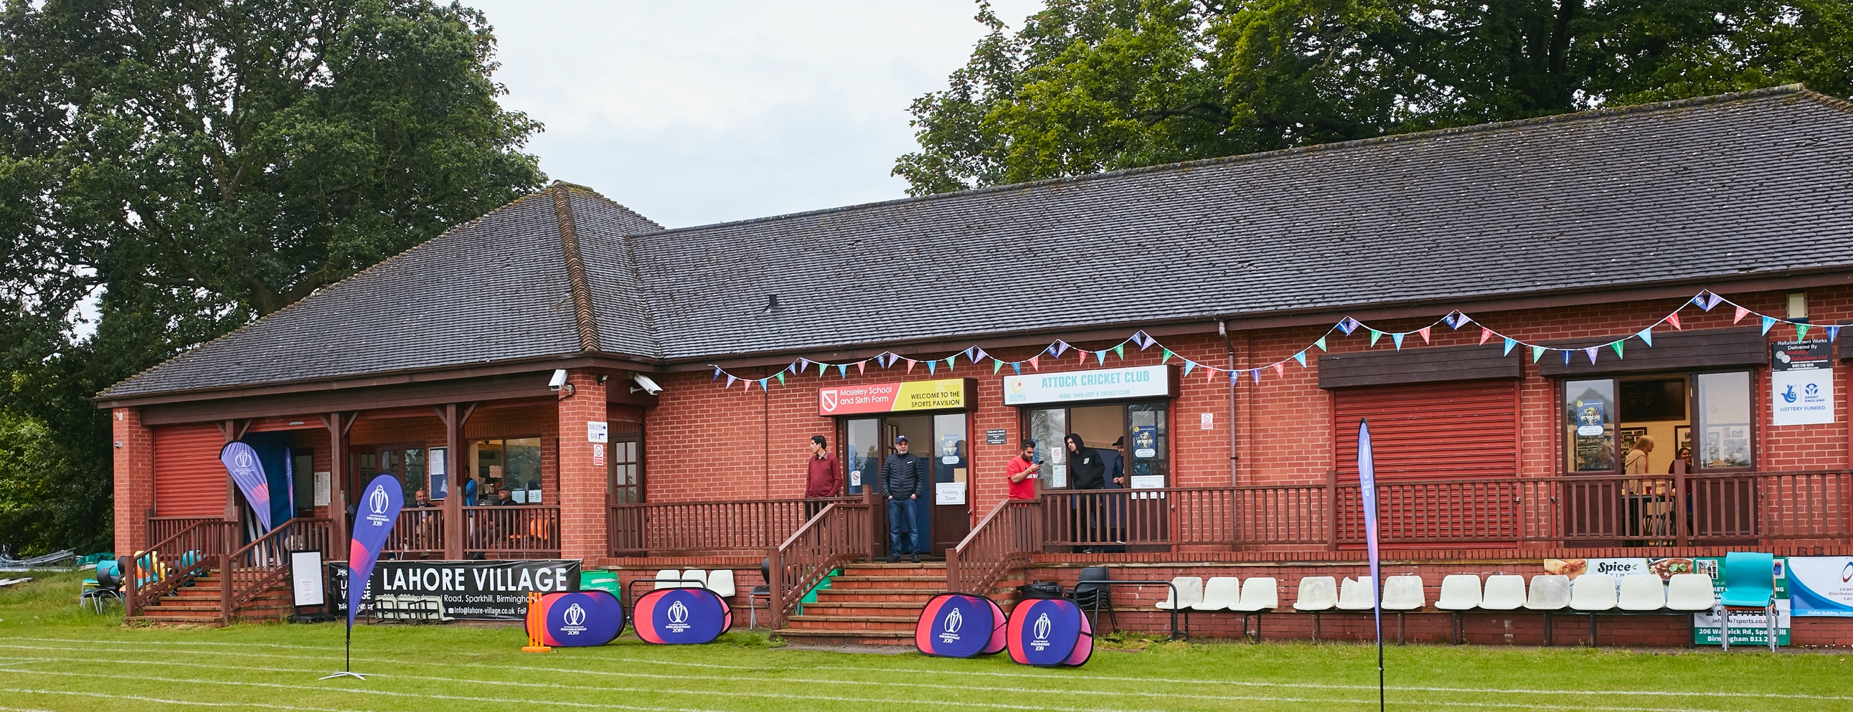

RISK ASSESSMENT TEMPLATE FOR CLUBS PREPARING TO OPEN THEIR CLUBHOUSE

Risk Assessment Template
As a facility provider, you should complete your own COVID-19 Risk Assessment and publish this to your users.

If you are not the facility provider, then you should consider which sections will apply to your clubs individual situation upon returning to play and complete a risk assessment based on your activity, including (but not limited to) people management and communication, hygiene and first aid. You may still wish to record that you have assessed facility risks through enquiries made with your facility provider.

We have provided an example risk assessment below, which is for illustrative purposes only, and includes some examples of things to consider. Consider how this will apply to each aspect of your operation and identify the controls you require to meet Government guidance regarding health, social distancing and hygiene etc. Remember that you must review your other Health and Safety, and Safeguarding, risk assessments for other hazards such as fire, first aid etc.

What are the hazards? |  | Transmission of COVID-19
Who might be harmed? |  | Facility users, staff, volunteers, visitors and the wider community
No | Controls required |  | Action Taken by the Club
People Management and Communication
 | Self-screening of individuals before they arrive at the venue to ensure individuals displaying COVID-19 symptoms or those who should be shielding do not travel or attend. |  | Individuals are advised and they Check themselves to make sure there are no symptoms.
 | An assessment of user numbers, space capacities, venue circulation and layout planning to maintain social distancing. |  | Individuals have been advised about social distancing. There will be total 15 players on the ground and the opposition team will be advised about the precautions taken
 | A plan for where parents and players will sit whilst watching cricket activities. |  | No audience or spectators.
 | Signage and communication so that all participants and visitors are aware of the control measures in place and how to act appropriately to minimise the risk of transmission of COVID-19. |  | Individuals have been advised and signage will be made available.
 | Staff and volunteer training to support the implementation of the plan, with suitable training records. |  | Welfare officer and captain are well aware about the measures taken
Buildings
 | Assess ventilation in your building (natural and mechanical) and take appropriate measures to maximise ventilation and minimise risk of transmission. |  | Yes. No access provided to the building, except the toilet
 | Assess the maximum occupancy of your rooms at 2m social distancing (or 1m with risk mitigation where 2m is not possible) and establish a suitable circulation system/one-way system. Use signage and floor markings to communicate this. |  | Not applicable.
 | Assess the arrangement of seating areas to maintain social distancing and minimise the risk of transmission. |  | Not applicable.
 | Consider your wet weather plans and describe what actions you will take to maintain social distancing in wet weather. |  | Individuals will be asked to wait in their respective cars
Social and Hospitality Areas
 | Plan to solicit and maintain records of your member attendance, customers and visitors - to be maintained for 21 days and then destroyed. |  | Only players visit the ground on the day. We have that records in the form of team list. If any visitors arrive at the site a record will be kept. If the ground we are playing is a shared public area we will not be keeping any records of people pass by, however the players will follow social distancing with them
 | Identification of suitable areas for outdoor service that don’t overlap with cricket activity. |  | As above
 | Steps taken to minimise time and the number of people at the bar. |  | Not applicable.
 | Steps taken to minimise contact points at payment or around the hospitality space. |  | Not applicable.
 | Suitable PPE provision and training for staff and volunteers. |  | Not applicable.
 | Strategy for the safe serving, clearing and cleaning of glassware and tableware. |  | Not applicable.
 | Deep cleaning strategy to minimise COVID-19 transmission risk |  | Toilet is cleaned weekly prior to the match
 | Daily cleaning strategy to minimise COVID-19 transmission risk. |  | Not applicable.
 | High-frequency touchpoint cleaning strategy to minimise COVID-19 transmission risk and how you will keep records. |  | Not applicable.
Hygiene and Cleaning
 | Materials, PPE and training that you have provided to your staff for effective cleaning. |  | No PPE required. There will be one person in the building at one time.
 | Provision of hand washing facilities with warm water, soap, disposable towels and bin. |  | Yes all these will be provided
 | Provision of suitable hand sanitiser in locations around the facility to maintain frequent hand sanitisation. |  | Yes hand sanitizers will be provided
 | Provision of suitable wipes and hand sanitiser on the field for hygiene breaks. |  | Wipes and hand sanitizers provided
 | What are the hazards? | Other venue hazards to be considered after temporary closure such as Legionnaire’s Disease, fire, electrical safety etc.
 | Who might be harmed? | Facility users, staff, volunteers and visitors
 | Controls required |  | Action Taken by the Club
Preparing Your Buildings
 | Consider the risk of Legionnaire’s disease and carry out necessary work to make your water supply safe for users. Refer to the specific guidance in the document above. |  | The building will be used for just toilet. No tea, drinking water, etc will be provided.
 | Check that routine maintenance has not been missed and certification is up to date (e.g. Gas safety, Electrical Safety and Portable Appliance Testing, Fire Safety, Lifts and Heating – Ventilation and Air Conditioning). |  | Not applicable. The building has got no gas and electricity supply. The electricity is generated by a portable generator which is being checked and certified.
 | Check that your ground is ready and safe to play. Look at what work is required and how this can be done safely at a social distance. |  | Big ground with lots of open space, players will be standing at a good distance from each other.
 | What are the hazards? | Vital first aid equipment is not available when needed. First aiders do not have adequate PPE to carry out first aid when required.
 | Who might be harmed? | First aiders, facility users, staff, volunteers and visitors
 | Controls required |  | Action Taken by the Club
First Aid
 | Check that your first aid kits are stocked and accessible during all activity. |  | First aid kit is available
 | What steps have you taken to improve your first aiders’ understanding of first aid provision under COVID-19? |  | Firs aiders have all got mask and gloves and they have been advised how to sanitize the affected areas, etc.
 | If you have an AED then check that it is in working order, service is up to date and that it is available during all activity. |  | Not applicable
 | What are the hazards? | Pitches or outfield are unsafe to play on
 | Who might be harmed? | Players, officials, ground staff
 | Controls required |  | Action Taken by the Club
Preparing your Grounds
 | Safety checks on machinery, sightscreens and covers. |  | Not applicable.
 | Check and repair of any damage to pitches and outfields. |  | Not applicable
 | Surfaces checked and watering regime adjusted based on lack of rainfall. |  | Not applicable.
 | What are the hazards? | Use this space to identify hazards at your venue
 | Who might be harmed? | Use this space to identify who might be harmed
 | Controls required |  | Action Taken by the Club
 | Players Safety |  | Players have been advised to bring their own kits and equipment.
 |  |  | Players have been advised to travel individually in separate cars
 |  |  | Players have been advised to not celebrate with high fives and hugs.
 |  |  | Players have been advised to bring their own drinks and food.
 |  |  | Players have been asked sit in their respective cars in case of adverse weather.

 | What are the hazards? | Use this space to identify hazards at your venue
 | Who might be harmed? | Use this space to identify who might be harmed
 | Controls required |  | Action Taken by the Club
 | Identify your own control measures required. |  | None

 | What are the hazards? | Use this space to identify hazards at your venue
 | Who might be harmed? | Use this space to identify who might be harmed
 | Controls required |  | Action Taken by the Club
 | Identify your own control measures required.

