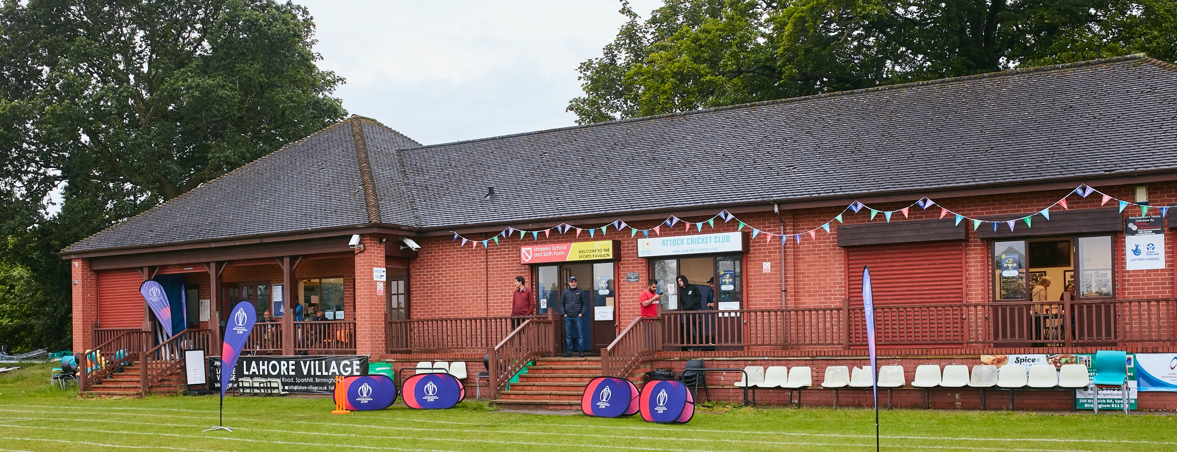

RISK ASSESSMENT TEMPLATE FOR CLUBS PREPARING TO OPEN THEIR CLUBHOUSE

Risk Assessment Template
As a facility provider, you should complete your own COVID-19 Risk Assessment and publish this to your users.

If you are not the facility provider, then you should consider which sections will apply to your clubs individual situation upon returning to play and complete a risk assessment based on your activity, including (but not limited to) people management and communication, hygiene and first aid. You may still wish to record that you have assessed facility risks through enquiries made with your facility provider.

We have provided an example risk assessment below, which is for illustrative purposes only, and includes some examples of things to consider. Consider how this will apply to each aspect of your operation and identify the controls you require to meet Government guidance regarding health, social distancing and hygiene etc. Remember that you must review your other Health and Safety, and Safeguarding, risk assessments for other hazards such as fire, first aid etc.

What are the hazards? |  | To prevent the transmission of COVID-19
Who might be harmed? |  | Facility users (Home & Away players) visitors and the wider community
No | Controls required |  | Action Taken by the Club
People Management and Communication
 | Self-screening of individuals before they arrive at the venue to ensure individuals displaying COVID-19 symptoms or those who should be shielding do not travel or attend. |  | - Anyone displaying any symptoms of COVID – 19 (New continuous cough, high temperature & a loss of, or change in, normal sense of taste or smell) to stay at home and not attend.  - Individuals due to attend a match to use their own common sense on whether they are well enough to travel and attend.
 | An assessment of user numbers, space capacities, venue circulation and layout planning to maintain social distancing. |  | - To follow ECB guidelines on social distancing, the amount of players/visitors per match.  - QR code must be scanned by both Home, Away and visitors for Track and Trace purposes on arrival at Barrow Park.  - A sign sheet to be implemented for all attending who do not have access to Track and Trace app. Must include (Name and contact details) for NHS track and trace. (Details to be kept for 21 days then can be destroyed)  - To use a one-way system when entering and exiting the pavilion. Signage to be put up to show the entrance and exit doors.  - Seating area to be arranged 1m+ apart on pavilion balcony.
 | A plan for where parents and players will sit whilst watching cricket activities. |  | - Players to use the allocated seats on the balcony of the pavilion adhering to the layout. (No chairs to be moved from markers, to be wiped down and disinfected at the change of innings)  - Benches/chairs to be disinfected before used and placed 1+ meters  apart to maintain social distancing for visitors.  - Benches/chairs to be spread around the boundary edge for spectators.  - Any spectators not to gather in groups of more than 6 people. Unless from the same household.  - Where possible NO ONE is to gather or sit inside the pavilion.  - In the event of rain players/spectators to return to their own vehicles to maintain social distancing.
 | Signage and communication so that all participants and visitors are aware of the control measures in place and how to act appropriately to minimize the risk of transmission of COVID-19. |  | - The risk assessment is to be uploaded onto the Willey Wanderers website and at the cricket ground in sight for everyone to see.  - Players to read and familiarize themselves with the Risk Assessment.  - Signage to be displayed in easy to see appropriate places. To indicate the one-way system on entrance and exit doors. Toilets to be a one in one out system with instructions of hand washing/sanitizing guidelines from the government.  - Floor Markings to be displayed in seating area on balcony to adhere to the social distancing guidelines.
 | Home players to support the implementation of the plan. |  | - By reading the risk assessment provided.  - Communication between all who’s attending.
Buildings
 | Assess ventilation in your building (natural and mechanical) and take appropriate measures to maximize ventilation and minimize risk of transmission. |  | - To keep doors and windows open where possible to allow as much fresh air circulating through the pavilion.
 | Assess the maximum occupancy of your rooms at 2m social distancing (or 1m with risk mitigation where 2m is not possible) and establish a suitable circulation system/one-way system. Use signage and floor markings to communicate this. |  | - No one is to gather inside the pavilion unless it is an emergency.  - Changing rooms/showers not to be used. Players to arrive in cricket kit.  - The double doors at the front of the pavilion will be the entrance and the side door by the kitchen is to be the exit. Both with be displayed with signage and floor markings.  - Kitchen area to be a one in one out if needed to be used i.e. for water or to access the first aid box.
 | Assess the arrangement of seating areas to maintain social distancing and minimize the risk of transmission. |  | - All seating areas to be cleaned and disinfected before and after every cricket match.  - All seating to be laid out 1+ meters adhering to social distancing guidelines. Floor markings will be used to indicate this.
 | Consider your wet weather plans and describe what actions you will take to maintain social distancing in wet weather. |  | - During any wet weather all players and visitors to return to their own cars for shelter and to maintain social distancing.
Social and Hospitality Areas
 | Plan to solicit and maintain records of your member attendance, and visitors - to be maintained for 21 days and then destroyed. |  | - To have a written record of all whom attend each match with their names and contact details for NHS track and trace.
 | Identification of suitable areas for outdoor service that don’t overlap with cricket activity. |  | - N/A
 | Steps taken to minimize time and the number of people at the bar. |  | - N/A.  - If players/visitors require drinks they are to bring there own and dispose of them correctly, using bins provided.
 | Steps taken to minimize contact points at payment or around the hospitality space. |  | - N/A
 | Suitable PPE provision. |  | - Hand sanitizer to be provided at the entrance and exit to the pavilion.  - Anti – Bacterial hand wash and sanitizer provided in all hand washing facilities. With disposable one use paper towels to dry your hands.  - If the score board is to be used the person allocated to do this must wear disposable gloves.  - Anyone needing to give any first aid will be provided with full PPE. (Face mask, apron & gloves)
 | Strategy for the safe serving, clearing and cleaning of glassware and tableware. |  | - N/A – All attending to use own cups, bottles, plates etc. and clear any rubbish away in bins provided.
 | Deep cleaning strategy to minimize COVID-19 transmission risk |  | - A deep clean of all surfaces, touch points, toilets, seating areas, kitchen to be carried out by a member of the club every week.
 | Daily cleaning strategy to minimize COVID-19 transmission risk. |  | - To be held on a Saturday and Sunday before and after a match.
 | High-frequency touchpoint cleaning strategy to minimize COVID-19 transmission risk and how you will keep records. |  | - To allocate someone every hour to clean/disinfect all touchpoint surfaces and to record on a cleaning rota.
Hygiene and Cleaning
 | Materials, PPE that you have provided for effective cleaning. |  | - Anti – bacterial spray for all surfaces.  - In toilet areas Anti – Bacterial hand wash and hand sanitizer to be provided.  - Face mask, gloves and a disposable apron to be provided in first aid box if needed.  - Hand sanitizer on entrance and exit doors.
 | Provision of hand washing facilities with warm water, soap, disposable towels and bin. |  | - To adhere to government hand washing guidelines. (20 seconds)  - In toilet areas to provide warm water, anti – bacterial hand wash and sanitizer. One use hand towels to dry hands and dispose of in bins provided.
 | Provision of suitable hand anitizat in locations around the facility to maintain frequent hand anitization. |  | - To be placed on entrance and exit doors, in toilet & kitchen areas.
 | Provision of suitable wipes and hand sanitizer on the field for hygiene breaks. |  | - To use anti-bacterial wipes or sanitizer provided and dispose of the wipes in bins provided.  - Individuals may supply their own sanitation to use.
 | What are the hazards? | Other venue hazards to be considered after temporary closure such as Legionnaire’s Disease, fire, electrical safety etc.
 | Who might be harmed? | Who might be harmed? Facility users (Home & Away players) visitors and the wider community  Controls required Action Taken by the Club
 | Controls required |  | Action Taken by the Club
Preparing Your Buildings
 | Consider the risk of Legionnaire’s disease and carry out necessary work to make your water supply safe for users. Refer to the specific guidance in the document above. |  | - The water tank has been cleaned and disinfected. Fresh water has been added.
 | Check that routine maintenance has not been missed and certification is up to date (e.g. Electrical Safety and Portable Appliance Testing, Fire Safety. |  | - All up to date.
 | Check that your ground is ready and safe to play. Look at what work is required and how this can be done safely at a social distance. |  | - Risk assessment completed. Displayed on website and in the pavilion.  - Necessary measures put in place.  - Signage and floor markings visible.  - Work parties of no more than 6 in a group adhering to social distancing completing groundwork.  - Deep clean of pavilion and toilet areas carried out weekly.
 | What are the hazards? | Vital first aid equipment is not available when needed. First aiders do not have adequate PPE to carry out first aid when required.
 | Who might be harmed? | First aiders, facility users, and visitors
 | Controls required |  | Action Taken by the Club
First Aid
 | Check that your first aid kits are stocked and accessible during all activity. |  | - First aid box checked weekly and fully stocked. Accessible in the kitchen area.
 | What steps have you taken to improve your first aiders’ understanding of first aid provision under COVID-19? |  | - All first aider’s to have familiarized themselves with new COVID – 19 provisions for first aid.  - Changing rooms only to be used if first aid is required.  - Full PPE provided for first aiders.
 | If you have an AED then check that it is in working order, service is up to date and that it is available during all activity. |  | - N/A
 | What are the hazards? | Pitches or outfield are unsafe to play on
 | Who might be harmed? | Players, officials, ground staff
 | Controls required |  | Action Taken by the Club
Preparing your Grounds
 | Safety checks on machinery, sightscreens and covers. |  | - All machinery, sight screens and covers to be checked on a weekly basis.
 | Check and repair of any damage to pitches and outfields. |  | - Pitch and outfield to be checked on a weekly basis and repairs carried out.
 | Surfaces checked and watering regime adjusted based on lack of rainfall. |  | - Adjusted accordingly to guidelines on lack of rainfall.
 | What are the hazards? | Food preparation areas.
 | Who might be harmed? | Players, Volunteers, Visitors
 | Controls required |  | Action Taken by the Club
 | Making of food and drinks. |  | - Players have been asked to provide their own food and drinks during a match. (No food/drinks to be prepared/consumed in the kitchen area)  - All rubbish to be disposed of using bins provided.  - No use of cups, plates, cutlery.

 | What are the hazards? | Use of the score board
 | Who might be harmed? | Person allocated to do scoring of the match
 | Controls required |  | Action Taken by the Club
 | To prevent transmission of COVID – 19 |  | - Person allocated to do the scoring to wear gloves when handling the number tiles to prevent the transmission of COVID – 19.  - To look at possible alternatives to display the match information. E.g. White board and pen.

 | What are the hazards? | Use this space to identify hazards at your venue
 | Who might be harmed? | Use this space to identify who might be harmed
 | Controls required |  | Action Taken by the Club
 | Identify your own control measures required.

