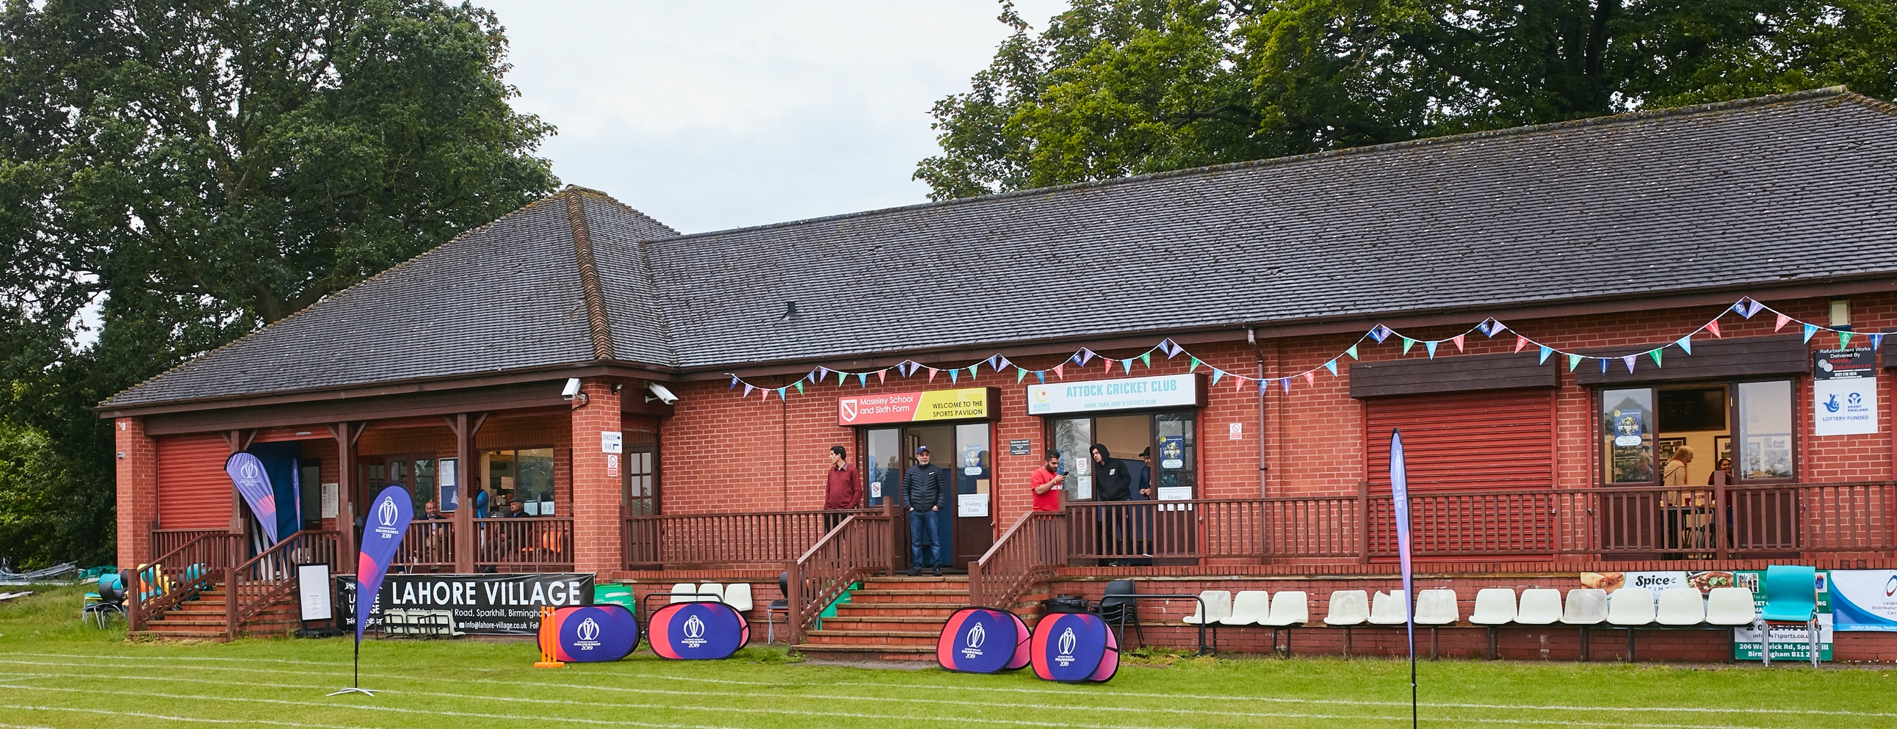

RISK ASSESSMENT FOR OPENING ELLESMERE CRICKET CLUBHOUSE

Risk Assessment

What are the hazards? |  | Transmission of COVID-19
Who might be harmed? |  | Facility users, staff, volunteers, visitors and the wider community
No | Controls required |  | Action Taken by the Club
People Management and Communication
 | Self-screening of individuals before they arrive at the venue to ensure individuals displaying COVID-19 symptoms or those who should be shielding do not travel or attend. |  | Notification made to all members that if displaying signs of Covid-19 then to self-isolate. All members have been informed that if they are symptomatic and/or living in a household with a possible COVID-19 infection they should remain at home and follow UK Government guidance. Communication has been emailed and via social media
 | An assessment of user numbers, space capacities, venue circulation and layout planning to maintain social distancing. |  | The limited area that is open will be clearly marked / signed and 2m distances marked. One in, one out system for both the male and female toilets. One person allowed in kitchen/bar area.
 | A plan for where parents and players will sit whilst watching cricket activities. |  | Seating at either end of the pavilion for home and away teams.
 | Signage and communication so that all participants and visitors are aware of the control measures in place and how to act appropriately to minimise the risk of transmission of COVID-19. |  | Signage displayed in appropriate areas as well as floor markings. Away team to receive information prior to match on control measures in place
 | Staff and volunteer training to support the implementation of the plan, with suitable training records. |  | All members notified of the requirements and a copy of this risk assessment is on display and has been shared with club members. Committee members to control implementation & training
Buildings
 | Assess ventilation in your building (natural and mechanical) and take appropriate measures to maximise ventilation and minimise risk of transmission. |  | All pavilion doors will be open to allow ventilation.
 | Assess the maximum occupancy of your rooms at 2m social distancing (or 1m with risk mitigation where 2m is not possible) and establish a suitable circulation system/one-way system. Use signage and floor markings to communicate this. |  | One way system implemented, floor guidance and signage displayed. Maximum occupancy of 6.
 | Assess the arrangement of seating areas to maintain social distancing and minimise the risk of transmission. |  | Seating removed to create appropriate space.
 | Consider your wet weather plans and describe what actions you will take to maintain social distancing in wet weather. |  | main room and pavilion veranda. Personnel vehicles can also be utilized
Social and Hospitality Areas
 | Plan to solicit and maintain records of your member attendance, customers and visitors - to be maintained for 21 days and then destroyed. |  | Home club members, customers and visitors information will be documented and maintained. ‘Away’ clubs are asked to bring a team sheet with full details of players and away visitors which can be left at the ground These will then be destroyed after 21 days
 | Identification of suitable areas for outdoor service that don’t overlap with cricket activity. |  | N/A
 | Steps taken to minimise time and the number of people at the bar. |  | Bar area will be restricted to a ‘1 in 1 out’ scenario. Markers will be placed on the floor. Queues for drinks to be socially distanced outside and floor markers will be evident. Scoring hatch to be used while indoor areas are restricred.
 | Steps taken to minimise contact points at payment or around the hospitality space. |  | Hand sanitizer and card payment available.
 | Suitable PPE provision and training for staff and volunteers. |  | Members aware of requirements of risk assessment. Facemasks, gloves and sanitizer provided.
 | Strategy for the safe serving, clearing and cleaning of glassware and tableware. |  | N/A
 | Deep cleaning strategy to minimise COVID-19 transmission risk |  | Pre-clean prior to use and post-clean after use.
 | Daily cleaning strategy to minimise COVID-19 transmission risk. |  | A clean as we go strategy.
 | High-frequency touchpoint cleaning strategy to minimise COVID-19 transmission risk and how you will keep records. |  | Sanitiser and wipes provided in these areas. All doors will be propped open where possible, cleaning products will be used to clean high touch points at times when the facilities are open
Hygiene and Cleaning
 | Materials, PPE and training that you have provided to your staff for effective cleaning. |  | Facemasks, gloves and sanitizer provided. All members notified of the requirements and a copy of this risk assessment is on display and has been shared with club members. Committee members to control implementation & training
 | Provision of hand washing facilities with warm water, soap, disposable towels and bin. |  | Provided in Both Female & Male Toilet facilities
 | Provision of suitable hand sanitiser in locations around the facility to maintain frequent hand sanitisation. |  | All visitors are required to use the sanitiser provided at the entrance to the club. Players / visitors are reminded to try and bring their own sanitiser. Sanitiser will be made available at numerous points within the cartilage of the ground. Good hand hygiene practices are encouraged through signage
 | Provision of suitable wipes and hand sanitiser on the field for hygiene breaks. |  | Table with sanitizer and wipes provided outside of pavilion provided.
 | What are the hazards? | Other venue hazards to be considered after temporary closure such as Legionnaire’s Disease, fire, electrical safety etc.
 | Who might be harmed? | Facility users, staff, volunteers and visitors
 | Controls required |  | Action Taken by the Club
Preparing Your Buildings
 | Consider the risk of Legionnaire’s disease and carry out necessary work to make your water supply safe for users. Refer to the specific guidance in the document above. |  | Guidance followed in advice document, water to have a fresh flow. Systems drained for winter and ran frequently to avoid any build up.
 | Check that routine maintenance has not been missed and certification is up to date (e.g. Gas safety, Electrical Safety and Portable Appliance Testing, Fire Safety, Lifts and Heating – Ventilation and Air Conditioning). |  | Testing up-to-date, fire extinguishers awaiting check once covid restrictions allow site visit.
 | Check that your ground is ready and safe to play. Look at what work is required and how this can be done safely at a social distance. |  | Ground work and cleaning has been done under Covid guidelines.
 | What are the hazards? | Vital first aid equipment is not available when needed. First aiders do not have adequate PPE to carry out first aid when required.
 | Who might be harmed? | First aiders, facility users, staff, volunteers and visitors
 | Controls required |  | Action Taken by the Club
First Aid
 | Check that your first aid kits are stocked and accessible during all activity. |  | First aid kits available in Kitchen & Home changing room. New kits purchased for 2021 season.
 | What steps have you taken to improve your first aiders’ understanding of first aid provision under COVID-19? |  | First aiders have been advised to follow government guidelines. Some club members are healthcare professionals.
 | If you have an AED then check that it is in working order, service is up to date and that it is available during all activity. |  | N/A
 | What are the hazards? | Pitches or outfield are unsafe to play on
 | Who might be harmed? | Players, officials, ground staff
 | Controls required |  | Action Taken by the Club
Preparing your Grounds
 | Safety checks on machinery, sightscreens and covers. |  | Checked / Ongoing review.
 | Check and repair of any damage to pitches and outfields. |  | Checked / Ongoing review.
 | Surfaces checked and watering regime adjusted based on lack of rainfall. |  | Checked / Ongoing review.
 | What are the hazards? | Use this space to identify hazards at your venue – Older facilities lack of entrance and exits.
 | Who might be harmed? | Use this space to identify who might be harmed - People attending the venue.
 | Controls required |  | Action Taken by the Club
 | Identify your own control measures required. |  | Main door locks fitted to restrict flow of movement.
 |  |  | Segregated the pavilion into 2 sections, both have separate entrances and exits.
 |  |  | Hand sanitizer and disposable towels provided.

 | What are the hazards? | Use this space to identify hazards at your venue – Payment of items/fees.
 | Who might be harmed? | Use this space to identify who might be harmed – Those using the facillties.
 | Controls required |  | Action Taken by the Club
 | Identify your own control measures required. |  | One member serving at bar.
 |  |  | PPE and disposable plastic cups provided.
 |  |  | Contactless payment available and encouraged.
 |  |  | Sanitiser and bins provided.

 | What are the hazards? | Use this space to identify hazards at your venue
 | Who might be harmed? | Use this space to identify who might be harmed
 | Controls required |  | Action Taken by the Club
 | Identify your own control measures required. |  | Regular review of government guidelines to ensure continued compliance.

