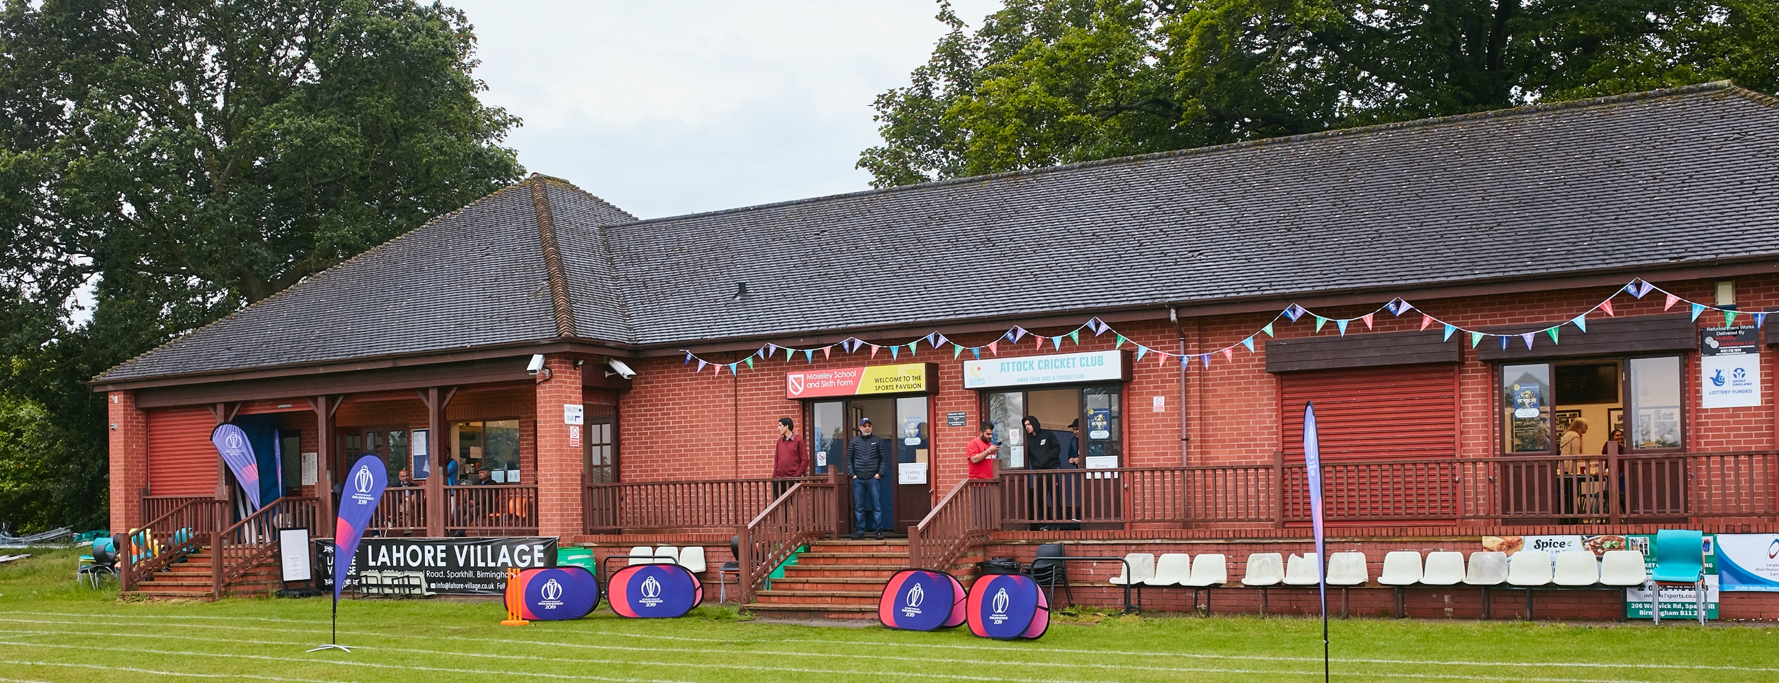

RISK ASSESSMENT TEMPLATE FOR CLUBS PREPARING TO OPEN THEIR CLUBHOUSE

What are the hazards? |  | Transmission of COVID-19
Who might be harmed? |  | Facility users, staff, volunteers, visitors and the wider community
No | Controls required |  | Action Taken by the Club
People Management and Communication
 | Self-screening of individuals before they arrive at the venue to ensure individuals displaying COVID-19 symptoms or those who should be shielding do not travel or attend. |  | All club members have been circulated the Coronavirus (Covid-19) Government Guidance. All Male/Female members above the ages of 13 eligible to play in organized games will be circulated again with the current Guidance. All teams and officials attending Frankwell for organised games will be sent a reminder to adhere to the current Government Guidance.
 | An assessment of user numbers, space capacities, venue circulation and layout planning to maintain social distancing. |  | An assessment has been carried out for all activities at Frankwell. Sufficient space identified for two matches to take place at same time with up to 30 players and officials at each game. Circulation is safe with sufficient space for social distancing. Boundary altered near pavilion to improve space at possible pinchpoint. Players for Pitch Number 2 to go straight to that pitch on entry to ground.
 | A plan for where parents and players will sit whilst watching cricket activities. |  | Areas identified to facilitate social distancing whilst watching cricket activities and to separate attendees of both teams. Sufficient space for all members of the public allowed to enter public areas to be able to either remain to watch cricket or move around ground in safe socially distanced manner.
 | Signage and communication so that all participants and visitors are aware of the control measures in place and how to act appropriately to minimise the risk of transmission of COVID-19. |  | Signage in place both fixed and portable to warn all attendees and passing public of the need for social distancing and good hygiene to minimize risks of transmission. Further guidance will be sent to players.
 | Staff and volunteer training to support the implementation of the plan, with suitable training records. |  | All officers of club have been made aware of the Guidance and how Beacon CC are adapting to it. Further notifications as Guidance changes.
Buildings
 | Assess ventilation in your building (natural and mechanical) and take appropriate measures to maximise ventilation and minimise risk of transmission. |  | All methods of ventilation assessed. Ground Floor Changing room will be used for toilets and private area for putting on cricket protection equipment so extractor fan will be in operation and main door and fire door left open for ventilation.  1st Floor areas will have window ventilation to left, right and rear with main door left open. !st Floor will not be used by players and officials other than balcony for scorebox..
 | Assess the maximum occupancy of your rooms at 2m social distancing (or 1m with risk mitigation where 2m is not possible) and establish a suitable circulation system/one-way system. Use signage and floor markings to communicate this. |  | Toilets will be restricted to two persons at any one time to maintain social distancing. Oneway system not appropriate.  !st Floor will only be used by 1 person at a time for each toilet block.  Signage in place to warn of social distancing requirement, good hygiene practice and cleaning regime.
 | Assess the arrangement of seating areas to maintain social distancing and minimise the risk of transmission. |  | All seating will be outdoor in open areas and set at 1m social distancing with separate areas for attending teams.
 | Consider your wet weather plans and describe what actions you will take to maintain social distancing in wet weather. |  | All players and officials will be asked to return to their vehicles in wet weather.  Those without vehicles will be accommodated in gazebos with social distancing.
Social and Hospitality Areas
 | Plan to solicit and maintain records of your member attendance, customers and visitors - to be maintained for 21 days and then destroyed. |  | No social or hospitality areas in pavilion will be open. Details of all players, officials and visitors with their telephone contact details will be taken and kept for 21 days.
 | Identification of suitable areas for outdoor service that don’t overlap with cricket activity. |  | Outdoor Service from Pavilion door will be available during licensing hours and will be in the appropriate areas as identified earlier for players, officials and visitors to safely social distance and not interfere with cricket activities.
 | Steps taken to minimise time and the number of people at the bar. |  | Signage will be in place to maintain numbers approaching the pavilion to one person and there will be no entry to the pavilion.
 | Steps taken to minimise contact points at payment or around the hospitality space. |  | No entry to pavilion and contact less payment to minimize contact points.
 | Suitable PPE provision and training for staff and volunteers. |  | Non entry to pavilion and barrier at door to maintain social distancing for officer of club dealing with bar sales. Gloves, sanitizer, mask, disinfectant spray and paper towel in place.
 | Strategy for the safe serving, clearing and cleaning of glassware and tableware. |  | No entry to pavilion and barrier at pavilion door to safeguard server. No glassware will be used and all drinks sold in bottle or can, wine served in bottle with disposable glass. Rubbish bins for disposal marked where appropriate for recycling.
 | Deep cleaning strategy to minimise COVID-19 transmission risk |  | 1st Floor of Pavilion deep cleaned prior to start of season.  Ground floor and disabled toilet completely power washed and cleaned in March 21 during lockdown. Will be cleaned prior to start of season.
 | Daily cleaning strategy to minimise COVID-19 transmission risk. |  | New cleaning regime. Council will clean pavilion once a week. Toilets will be cleaned before and after events/matches. All touch points cleaned before and after events.  All touchpoints cleaned at regular hourly intervals during events/matches and attendees asked to clean touchpoints used before exiting.
 | High-frequency touchpoint cleaning strategy to minimise COVID-19 transmission risk and how you will keep records. |  | As above.  Cleaning by person in charge to be recorded on lists attached to wall at critical points on Ground and First Floor as reminders.
Hygiene and Cleaning
 | Materials, PPE and training that you have provided to your staff for effective cleaning. |  | No training. All officers attending pavilion have been made aware of the need to follow good hygiene and cleaning practices. Disposable gloves, rubber gloves, disinfectant, sprays, gel, paper towel all provided for hygiene, cleaning and safety of officers.
 | Provision of hand washing facilities with warm water, soap, disposable towels and bin. |  | Hand washing facilities situated in all toilets with hot and cold water, soap, gel, paper towels and bins.
 | Provision of suitable hand sanitiser in locations around the facility to maintain frequent hand sanitisation. |  | Soap dispensers fitted in all toilet areas. Hand sanitizer situated at entrance to pavilion, kitchen, all toilet entrances with signage to remind visitors to facility including players and officials.
 | Provision of suitable wipes and hand sanitiser on the field for hygiene breaks. |  | Table to be situated at edge of playing area with hand sanitizer, disinfectant spray and paper towel.
 | What are the hazards? | Other venue hazards to be considered after temporary closure such as Legionnaire’s Disease, fire, electrical safety etc.
 | Who might be harmed? | Facility users, staff, volunteers and visitors
 | Controls required |  | Action Taken by the Club
Preparing Your Buildings
 | Consider the risk of Legionnaire’s disease and carry out necessary work to make your water supply safe for users. Refer to the specific guidance in the document above. |  | Facility owned by Shrewsbury Town Council who confirm that a plumber has attended and ensured water supply is safe to use.  Showers are not in use and will be checked again prior to their use if Government Guidance should change to allow this.
 | Check that routine maintenance has not been missed and certification is up to date (e.g. Gas safety, Electrical Safety and Portable Appliance Testing, Fire Safety, Lifts and Heating – Ventilation and Air Conditioning). |  | As above. Plumber, Electrician, Sewage Technician and Fire Extinguisher Operative have attended Pavilion in last 4 weeks to ensure that facility certification is up to date and that all systems and equipment is working correctly and safely in normal and emergency situations.
 | Check that your ground is ready and safe to play. Look at what work is required and how this can be done safely at a social distance. |  | Ground is owned by Shrewsbury Town Council who employ a Professional Groundsman to maintain the facility and who is well versed in Social Distance working. The club work extremely well with the Groundsman to ensure the area is safe both to play, practice and for the general public using the open space.
 | What are the hazards? | Vital first aid equipment is not available when needed. First aiders do not have adequate PPE to carry out first aid when required.
 | Who might be harmed? | First aiders, facility users, staff, volunteers and visitors
 | Controls required |  | Action Taken by the Club
First Aid
 | Check that your first aid kits are stocked and accessible during all activity. |  | First Aid Kit located in marked First Aid cupboard in 1st Floor of Pavilion. Checked and stocked to the standards of initial First Aid response.  Disposable gloves and masks to be made available for First Aiders.
 | What steps have you taken to improve your first aiders’ understanding of first aid provision under COVID-19? |  | First Aiders have been requested to visit the St John Ambulance website and make themselves aware of the Guidance to First Aiders and Covid-19.  The Guidance is also displayed on the First Aid Cupboard.
 | If you have an AED then check that it is in working order, service is up to date and that it is available during all activity. |  | Not available at the location.
 | What are the hazards? | Pitches or outfield are unsafe to play on
 | Who might be harmed? | Players, officials, ground staff
 | Controls required |  | Action Taken by the Club
Preparing your Grounds
 | Safety checks on machinery, sightscreens and covers. |  | Shrewsbury Town Council own and maintain grounds machinery which is locked in brick building and Beacon CC have no means of entry or access to it.  Sightscreens and covers checked Thursday 3rd Aprily and no issues. Safety checks carried out prior to every game.
 | Check and repair of any damage to pitches and outfields. |  | Shrewsbury Town Council own ground and Professional Groundsman maintains ground to safe standard. Further check made prior to start of play.
 | Surfaces checked and watering regime adjusted based on lack of rainfall. |  | Shrewsbury Town Council own the ground and as such have a responsibility to the ratepayer to maintain a robust watering regime with conservation in mind.
 | What are the hazards? | Members of the Public using Frankwell under Covid-19 situation.
 | Who might be harmed? | Members of Public not associated with club or visiting team.
 | Controls required |  | Action Taken by the Club
 | Identify your own control measures required. |  | Use of signage and physical presence of players to enforce the message of social distancing.

 | What are the hazards? | Members of Shrewsbury Rowing Club collecting and returning equipment to storage containers on site.
 | Who might be harmed? | Players, officials, club members and spectators.
 | Controls required |  | Action Taken by the Club
 | Identify your own control measures required. |  | Chairman has spoken to Rowing Club and alerted them to the commencement of cricket and the need to be aware of club activities especially near to the pavilion.  Boundary moved 3m to allow a safer corridor in front of pavilion to avoid injuries and maintain social distancing.  Reminder that there will be more vehicular traffic in and around the car park especially with the need for players to arrive in separate vehicles.

 | What are the hazards? | Use this space to identify hazards at your venue
 | Who might be harmed? | Use this space to identify who might be harmed
 | Controls required |  | Action Taken by the Club
 | Identify your own control measures required.

