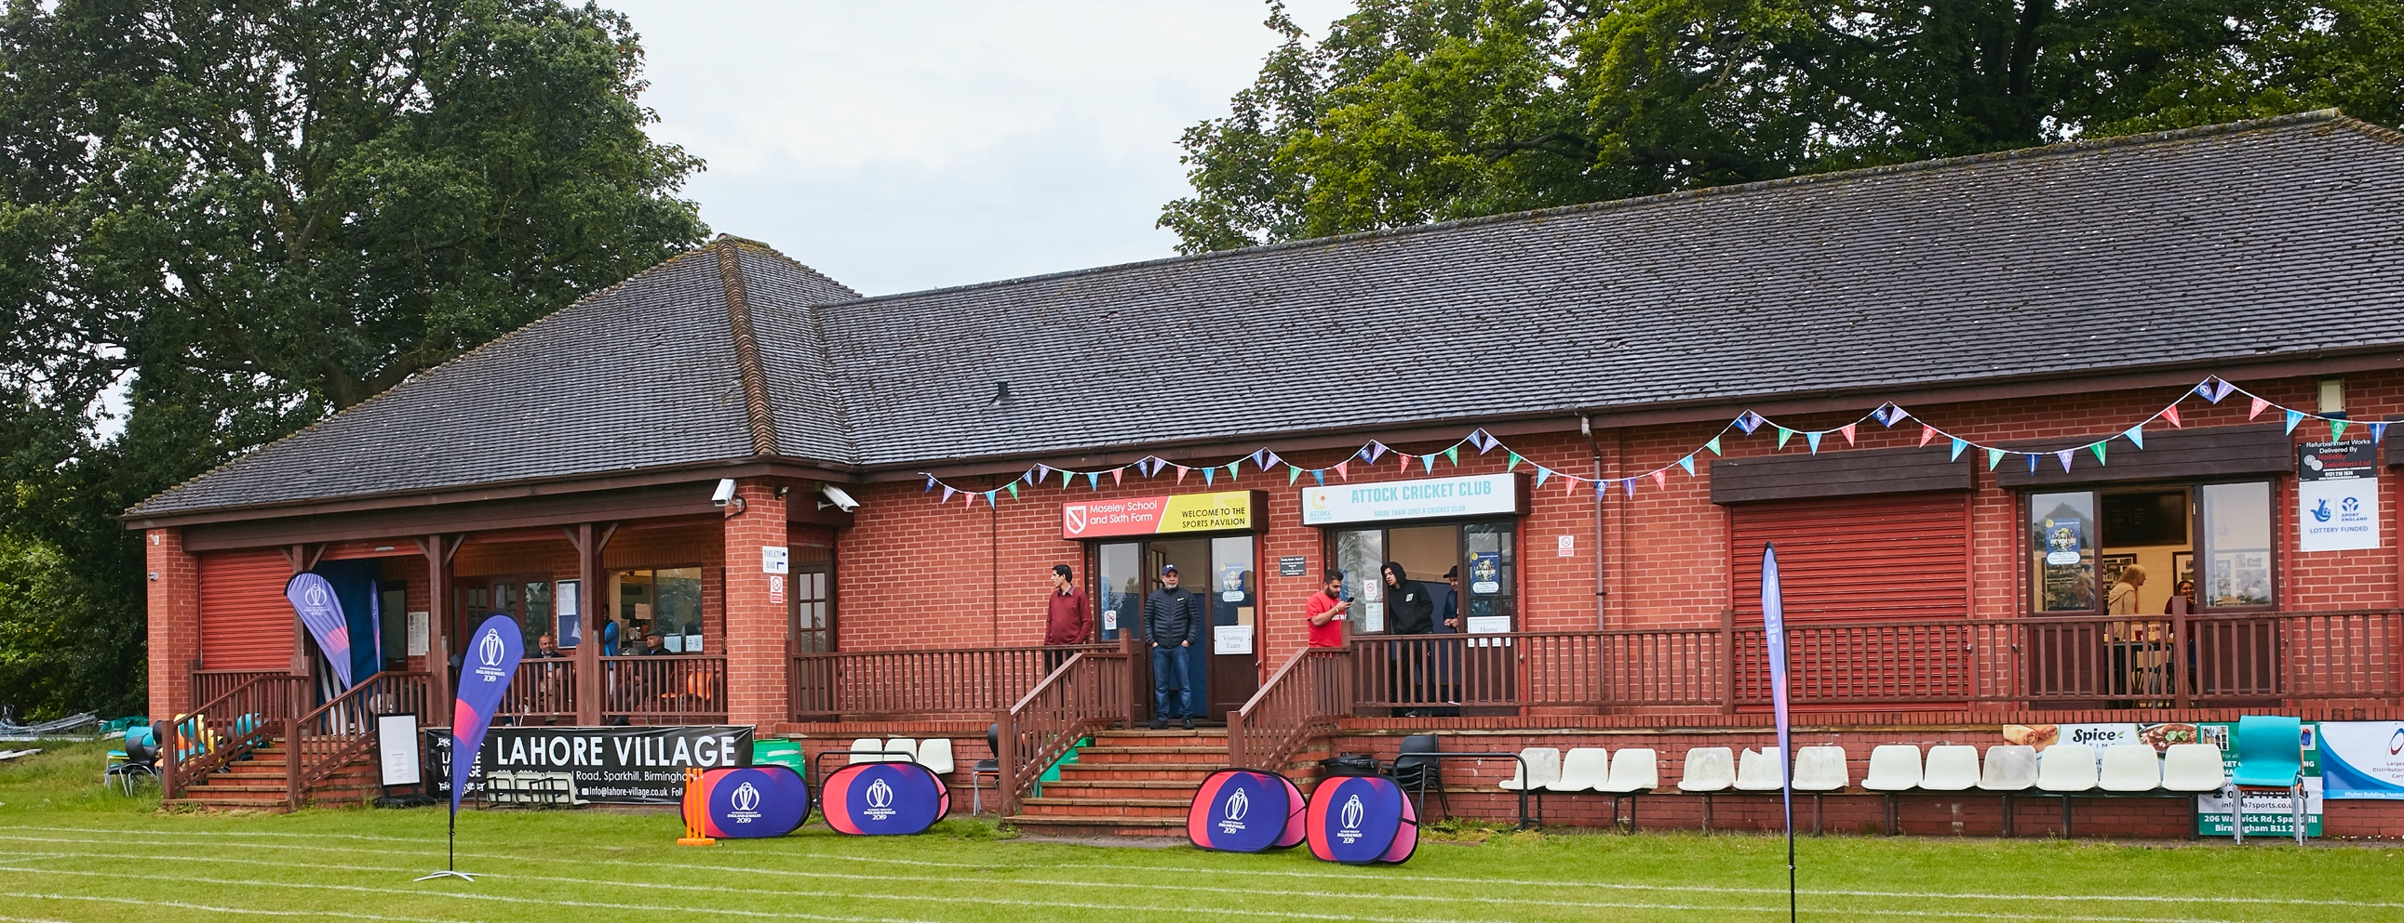

RISK ASSESSMENT TEMPLATE FOR CLUBS PREPARING TO OPEN THEIR CLUBHOUSE

Risk Assessment Template
As a facility provider, you should complete your own COVID-19 Risk Assessment and publish this to your users.

If you are not the facility provider, then you should consider which sections will apply to your clubs individual situation upon returning to play and complete a risk assessment based on your activity, including (but not limited to) people management and communication, hygiene and first aid. You may still wish to record that you have assessed facility risks through enquiries made with your facility provider.

We have provided an example risk assessment below, which is for illustrative purposes only, and includes some examples of things to consider. Consider how this will apply to each aspect of your operation and identify the controls you require to meet Government guidance regarding health, social distancing and hygiene etc. Remember that you must review your other Health and Safety, and Safeguarding, risk assessments for other hazards such as fire, first aid etc.

What are the hazards? |  | Transmission of COVID-19
Who might be harmed? |  | Facility users, staff, volunteers, visitors and the wider community
No | Controls required |  | Action Taken by the Club
People Management and Communication
 | Self-screening of individuals before they arrive at the venue to ensure individuals displaying COVID-19 symptoms or those who should be shielding do not travel or attend. |  | Follow government guidance, if in doubt do not come to the club
 | An assessment of user numbers, space capacities, venue circulation and layout planning to maintain social distancing. |  | Club house to only be used for toilet access. We do don’t have a bar or catering outlet
 | A plan for where parents and players will sit whilst watching cricket activities. |  | Sit outside and observe 2 metre social distancing. Bring own portable chairs if required
 | Signage and communication so that all participants and visitors are aware of the control measures in place and how to act appropriately to minimise the risk of transmission of COVID-19. |  | ECB infographics to be placed in prominent positions in clubhouse, changing room doors, foyer
 | Staff and volunteer training to support the implementation of the plan, with suitable training records. |  | We do not have any staff. Just players who are fully aware of the COVID rules as set out by the govt guidance
Buildings
 | Assess ventilation in your building (natural and mechanical) and take appropriate measures to maximise ventilation and minimise risk of transmission. |  | When games are in place, doors to club and changing room doors to be open.
 | Assess the maximum occupancy of your rooms at 2m social distancing (or 1m with risk mitigation where 2m is not possible) and establish a suitable circulation system/one-way system. Use signage and floor markings to communicate this. |  | For toilet use, 1 person in the building at a time
 | Assess the arrangement of seating areas to maintain social distancing and minimise the risk of transmission. |  | Main room will not be in use during games
 | Consider your wet weather plans and describe what actions you will take to maintain social distancing in wet weather. |  | In wet weather, people will have to return to their cars
Social and Hospitality Areas
 | Plan to solicit and maintain records of your member attendance, customers and visitors - to be maintained for 21 days and then destroyed. |  | On game days, we will register players from home and away teams and any other visitors who come to watch
 | Identification of suitable areas for outdoor service that don’t overlap with cricket activity. |  | NA
 | Steps taken to minimise time and the number of people at the bar. |  | NA
 | Steps taken to minimise contact points at payment or around the hospitality space. |  | NA
 | Suitable PPE provision and training for staff and volunteers. |  | NA
 | Strategy for the safe serving, clearing and cleaning of glassware and tableware. |  | NA
 | Deep cleaning strategy to minimise COVID-19 transmission risk |  | Clubhouse toilets to be cleaned before each game and after each game
 | Daily cleaning strategy to minimise COVID-19 transmission risk. |  | Clubhouse is not used when there is no game
 | High-frequency touchpoint cleaning strategy to minimise COVID-19 transmission risk and how you will keep records. |  | Door handles to be sanitized on match days, before the start of the game and after anyone goes to the toilets in the home and away changing room
Hygiene and Cleaning
 | Materials, PPE and training that you have provided to your staff for effective cleaning. |  | Hand sanitizer, disinfectant wipes and disinfectant spray to be used in changing rooms, main club room closed during games
 | Provision of hand washing facilities with warm water, soap, disposable towels and bin. |  | In changing room toilets hand sanitizer, soap, hand dryers all working
 | Provision of suitable hand sanitiser in locations around the facility to maintain frequent hand sanitisation. |  | As above
 | Provision of suitable wipes and hand sanitiser on the field for hygiene breaks. |  | Players to be advised to bring their own hand sanitizer to carry in pocket when fielding. Hand sanitizer available on tables outside the clubhouse for drinks breaks
 | What are the hazards? | Other venue hazards to be considered after temporary closure such as Legionnaire’s Disease, fire, electrical safety etc.
 | Who might be harmed? | Facility users, staff, volunteers and visitors
 | Controls required |  | Action Taken by the Club
Preparing Your Buildings
 | Consider the risk of Legionnaire’s disease and carry out necessary work to make your water supply safe for users. Refer to the specific guidance in the document above. |  | Water supply is on mains and safe
 | Check that routine maintenance has not been missed and certification is up to date (e.g. Gas safety, Electrical Safety and Portable Appliance Testing, Fire Safety, Lifts and Heating – Ventilation and Air Conditioning). |  | All electrical and plumbing up to date and working
 | Check that your ground is ready and safe to play. Look at what work is required and how this can be done safely at a social distance. |  | Ground is ready for play
 | What are the hazards? | Vital first aid equipment is not available when needed. First aiders do not have adequate PPE to carry out first aid when required.
 | Who might be harmed? | First aiders, facility users, staff, volunteers and visitors
 | Controls required |  | Action Taken by the Club
First Aid
 | Check that your first aid kits are stocked and accessible during all activity. |  | First Aid kit is up to date. Additional PPE available
 | What steps have you taken to improve your first aiders’ understanding of first aid provision under COVID-19? |  | No changes. Visiting teams to administer first aid to their players if needed.
 | If you have an AED then check that it is in working order, service is up to date and that it is available during all activity. |  | NA
 | What are the hazards? | Pitches or outfield are unsafe to play on
 | Who might be harmed? | Players, officials, ground staff
 | Controls required |  | Action Taken by the Club
Preparing your Grounds
 | Safety checks on machinery, sightscreens and covers. |  | All ready and working
 | Check and repair of any damage to pitches and outfields. |  | All ready for games
 | Surfaces checked and watering regime adjusted based on lack of rainfall. |  | All ready for games
 | What are the hazards? | Use this space to identify hazards at your venue
 | Who might be harmed? | Use this space to identify who might be harmed
 | Controls required |  | Action Taken by the Club
 | Identify your own control measures required. |  | On match days :- 1. All players arrive in kit  2. Players to bring pocket hand sanitizer  3. Only toilets to be used in the clubhouse
4. No teas, players to bring own refreshments
5. Toilets to be cleaned before & after the game, touch surfaces to be sanitized after each usage
6. All food wrappers to be taken home after the game
7. Own portable seating advised to allow social distancing, otherwise sit on the ground

 | What are the hazards? | Use this space to identify hazards at your venue
 | Who might be harmed? | Use this space to identify who might be harmed
 | Controls required |  | Action Taken by the Club
 | Identify your own control measures required.

 | What are the hazards? | Use this space to identify hazards at your venue
 | Who might be harmed? | Use this space to identify who might be harmed
 | Controls required |  | Action Taken by the Club
 | Identify your own control measures required.

